RIDERSHIP RAMP-UP FOR FIXED-GUIDEWAY TRANSIT PROJECTS:

AN EVALUATION OF INITIAL RIDERSHIP VARIATION

A Thesis

presented to

the Faculty of California Polytechnic State University,

San Luis Obispo

In Partial Fulfillment

of the Requirements for the Degree

Master of Civil Engineering in Department of Civil and Environmental Engineering

by

Jill Elizabeth Shinn

December 2018

© 2018

Jill Elizabeth Shinn

ALL RIGHTS RESERVED

COMMITTEE MEMBERSHIP

|  |  |  |
| --- | --- | --- |
| TITLE: |  | Ridership ramp-up for fixed-guideway transit projects: An evaluation of initial ridership variation. |
| AUTHOR: |  | Jill Elizabeth Shinn |
| DATE SUBMITTED: |  | November 28 2018 |
| COMMITTEE CHAIR: |  | Carole Turley Voulgaris, Ph.D.,  Assistant Professor of Civil and Environmental Engineering |
| COMMITTEE MEMBER: |  | Anurag Pande, Ph.D.,  Assistant Professor of Civil and Environmental Engineering |
| COMMITTEE MEMBER: |  | Kimberley Mastako, Ph.D.,  Lecturer of Civil and Environmental Engineering |

ABSTRACT

Ridership ramp-up for fixed-guideway transit projects: An evaluation of initial ridership variation.

Jill Elizabeth Shinn

Performance-based planning and programming has increased in popularity for transit project funding in recent years. This methodology focuses on quantitative performance measures to inform decision making. For transit projects, projections or observed ridership is the most commonly used performance measure to evaluate project benefits. Conventional wisdom within the transit industry suggests that measuring the performance of a transit project immediately after project opening may not capture all the project’s benefits, since it takes time for a project to realize its short-term ridership potential, a process commonly referred to as ridership ramp-up. While this idea is both intuitive and appealing, especially for projects that seem to be underperforming in their initial years, there is a need for empirical analysis to determine the typical magnitude and extent of ridership ramp up in order to better account for ramp-up in ridership forecasting and transit project evaluation. The purpose of this study is to meet this need by evaluating variations in ridership in the initial years after project opening for 55 fixed-guideway rail transit projects in the United States. I applied a fixed-effects regression model to predict one-year increases in ridership in each of the first five years after project opening, controlling for variation in gas prices, population, income, and unemployment. I find that ridership on new rail transit projects increases on average six percent controlling for other factors between the opening year and the first year after project opening. These findings can support decisions about how to account for ridership ramp up in forecasting and performance evaluation for rail transit projects.

Keywords: Performance-based planning and programming, transit, ridership, ramp-up, transit project funding, fixed-guideway rail transit

ACKNOWLEDGMENTS

I would like to thank Cal Poly, San Luis Obispo for a great platform to have my undergraduate and graduate education. The opportunities presented through courses, outside clubs, and the students are one of a kind.

Thank you to my friends and family who have supported me throughout my undergraduate and graduate careers at Cal Poly. To my dad for inspiring me to be a civil engineer. To my mom for always striving to help others. To my sister for being a role model of how working hard matters more than anything else. To Jonathan for always being an optimist and making sure I continue to have fun. To my puppy Oliver for being a very good boy.

I am very grateful for the guidance of Dr. Pande and Dr. Mastako for their support as my committee, and for encouraging me to pursue a career in transportation engineering. Finally, thank you to Dr. Voulgaris for guiding me throughout this process and being invaluable support for the past year.

TABLE OF CONTENTS

Page

List of Tables viii

List of Figures……………………………………………………………………………ix

1 Introduction 1

1.1 Purpose of Research 4

1.2 Research Tasks 4

2 Literature Review 6

2.1 Introduction 6

2.1.1 Federal Laws Regarding Transit System Performance 7

2.1.2 Ridership Forecasting 10

2.1.3 Importance of transit ridership and ridership evaluation 12

2.2 Existing Literature on Ridership Ramp-up 13

2.2.1 What is ridership ramp-up? 13

2.2.2 What causes ridership ramp-up? 15

2.2.3 How much error is explained by ridership ramp-up? 15

2.2.4 How do different experts estimate ramp-up? 18

2.3 What are other Factors that Influence Transit Ridership? 19

2.3.1 External factors that influence ridership 19

2.3.2 Internal factors that influence ridership 21

2.4 Conclusion 23

3 Methodology 25

3.1 Identifying Sample Data 25

3.1.1 Opening year definition 28

3.2 Descriptive Data Analysis Methodology 29

3.3 Qualitative Data Sample Selection 30

3.3.1 Excluded Projects 30

3.3.2 First year after opening outliers 33

3.4 Identifying Control Variables 40

3.4.1 Gas Price 40

3.4.2 Population 41

3.4.3 Unemployment Rate 41

3.4.4 Agency Operating Budget 42

3.4.5 Percent Growth of System 43

3.4.6 Income 43

3.4.7 Unidentified Control Variables 44

3.5 Regression Analysis Methodology 45

3.5.1 Regression Model 46

3.5.2 Clustered standard error analysis 48

3.5.3 Statistical Significance 48

3.6 Conclusions of methodology 49

4 Results 50

4.1 Descriptive Analysis Results 50

4.1.1 Findings from descriptive data analysis 50

4.1.2 Data sorting 60

4.1.3 Conclusions from descriptive data analysis 65

4.2 Controlled Data Regression Analysis Results 65

4.2.1 Models 65

4.2.2 Results of regression models 66

4.2.3 Control variable significance 69

4.2.4 Results of regression analysis with outliers excluded 74

4.3 Conclusions from results 78

5 Conclusions and Discussion 79

5.1 Discussion of Results 79

5.1.1 Limitations and Assumptions 79

5.2 Conclusions from findings 82

5.3 Future Work 84

6 References 85

7 Appendix A – R Code Inputs 88

8 Appendix B- Database 95

9 Appendix C - Database Key 104

LIST OF TABLES

Table Page

**Table 1.** Performance measure laws since 1976 3

**Table 2.** Ramp-up duration estimate by source 18

**Table 3.** Projects included in study sample 27

**Table 4.** National Transit Database fixed-guideway modes included in analysis 32

**Table 5.** Control variables included or excluded in analysis 44

**Table 6.** Characteristics of ridership growth by number of years since project opening 51

**Table 7.** Results of Regression Analysis 67

**Table 8.** Regression results with outliers excluded from sample 74

LIST OF FIGURES

Figure Page

**Figure 1.** Ramp-up conceptual diagram 14

**Figure 2.** Conceptual model of factors influencing aggregate transit demand 23

**Figure 3.** Ridership for Sound Transit light rail after first full year of opening 33

**Figure 4.** Ridership and employment in computer systems design and related services for Alamont Corridor Express after first full year of opening 35

**Figure 5.** Ridership for MBTA light rail after first full year of opening 36

**Figure 6.** Ridership for Minneapolis Metro Rail after first full year of opening 37

**Figure 7.** Ridership for Seattle Sounder commuter rail after first full year of opening 38

**Figure 8.** Ridership for Tren Urbano in Puerto Rico after first full year of opening 39

**Figure 9.** Average percent growth of ridership since previous year 52

**Figure 10**. Percent of observations with increased ridership growth since prior year 53

**Figure 11**. Ramp-up conceptual diagram 54

**Figure 12.** Percent ridership growth in first year after project opening 55

**Figure 13.** Percent growth in second year after project opening 56

**Figure 14.** Percent ridership growth in third year after project opening 57

**Figure 15.** Percent ridership growth in fourth year after project opening 58

**Figure 16.** Percent ridership growth in fifth year after project opening 59

**Figure 17.** Percent change ridership since prior year by mode (LR, CR, HR) 61

**Figure 18.** Percent change in ridership since prior year for different mode (HR, MR) 62

**Figure 19.** Percent change year to year sorted by new line or extension 64

**Figure 20.** Increase in ridership by year after project opening, controlling for changes in population, gas price, income, and unemployment 68

**Figure 21.** Correlation between percent change in ridership and gas price 70

**Figure 22.** Correlation between percent change in ridership and population 71

**Figure 23.** Correlation between percent change in ridership and percent change in income 72

**Figure 24.** Correlation between percent change in ridership and unemployment rate 73

**Figure 25.** Increase in ridership since prior year controlling for gas price, income, unemployment rate, and population for data without outliers 76

**Figure 26.** Percent change ridership first year after opening for results with outliers compared to results without outliers 77

# Introduction

Performance-based planning and programming (PBPP) has increased in significance since the introduction of Moving Ahead for Progress in the 21st Century (MAP-21) in 2013 and Fixing America’s Surface Transportation Act (FAST Act) in 2015. PBPP is an evaluation approach that uses performance data to inform decision-makers on transportation project benefits. Predicted or observed ridership is the most common measure for evaluating transit project benefits, and will likely continue to be the most prevalent method in the future. However, measuring the performance of transit projects in terms of ridership is difficult because ridership varies over time, which raises the question of when ridership should be observed to evaluate the effectiveness of new transit projects. Some have suggested that opening year ridership is not a valid measure of performance because it takes time for a project to achieve its ridership potential.

There is an argument that transit projects should be evaluated in terms of measures other than ridership due to its variability, however, throughout time transit ridership has been the most common measure for evaluating the benefits of a transit project. Although, as the history of the New Starts program shows, it is not the only possible metric that can be used to evaluate the benefits of a transit project. The New Starts program funds transit-related projects that are over 300 million US dollars, a new fixed guideway system, an extension to an existing system, or a fixed guideway BRT system. While the relative importance of ridership as a measure of project benefits has varied over time, it has always been a key indicator of project benefits. The first policy for systematically evaluating federally-funded transit projects was created in 1976 when the Urban Mass Transit Administration (UMTA) announced it will evaluate projects based on cost effectiveness. However, the manner in which the costs and benefits would be measured was not specified until 1984, when UMTA defined cost effectiveness as the incremental cost per new rider. This indicated that ridership was the primary benefit of a new transit project between 1984 and 1991. In 1991, the FTA made significant changes to the legislative New Starts criteria through the Intermodal Surface Transportation Efficiency Act (ISTEA), which requires that additional project benefits be considered, including mobility improvements, environmental benefits, and operating expenses, in addition to ridership. In 2001 ridership was replaced in cost effectiveness calculation with Transportation System User Benefits, which are described as mobility improvements, environmental benefits, operating efficiencies, cost-effectiveness, existing land use, transit-supportive land use policies and future patterns, and other factors. For each of the projects the FTA would assign ratings and assign overall ratings as per TEA-21 for each proposed project (Daniel Duff, Edward J. Gill, Jr., and G. Kent Woodman 2009). Due to the complexity of this methodology and to simplify calculations, in 2013 the FTA determined that the benefits measure used in cost-effectiveness calculations was changed back to the operating cost per trip (“Proposed New Starts and Small Starts Policy Guidance” 2013). Throughout the various iterations the New Starts project alternatives analysis, ridership remained as a measurement of project benefits. Table 1 shows the timeline of laws and performance measures used to evaluate transit projects for the New Starts program since 1976.

**Table 1.** Performance measure laws since 1976

|  |  |  |
| --- | --- | --- |
| Year(s) | Mandated by Law/Regulation | Performance measures |
| 1976-1984 | UMTA 41 Fed. Reg. 41512 | Cost-effectiveness (undefined) |
| 1984-1991 | UMTA 49 Fed. Reg. 21284 | Cost per new rider (ridership) |
| 1991-2001 | ISTEA | Mobility improvements, environmental benefits, operating, ridership |
| 2001-2013 | SAFETEA-LU | Transportation System User Benefits |
| 2013-Present | MAP-21 | Operating cost per trip (ridership) |

A common criticism of transit projects is that ridership fails to achieve projected ridership levels. Through various studies researchers have found that most patronage estimates for rail projects are significantly inflated, whether this is through errors in forecasting models or optimism bias (Pickrell 1992). Some observers suggest that transit planners and decision makers are faced with the desire to inflate project ridership projections to get their projects built (Pickrell 1992; Flyvbjerg, Skamris Holm, and Buhl 2005). Since the FTA New Starts process has used ridership as the primary source of characterizing benefits of a project this introduces many issues in the way projects are funded.

## Purpose of Research

Ridership ramp-up is the takes time for a project to realize its short-term ridership potential. Typically, ramp-up is said to occur during the first few years after a transit project has opened (Dehornoy 2015; Flyvbjerg 2005; Chang et al. 2010).Since ridership is the most common measure of project benefits, understanding when to measure observed ridership after a project opens is crucial. This research will inform what year ramp-up occurs and how large of a difference it makes. Some critics argue that ramp-up may account for a large jump in ridership after a few years, while others claim that ridership is a modest increase over time. The difference ramp-up makes in ridership and when it occurs will inform transportation professionals when and if ramp-up should be accounted for their projects since ridership is the primary indicator of project benefits. This study of ridership ramp-up will inform forecasters how to adapt their forecasts to account for a ramp-up period, for the FTA and over governing agencies to wait a specified number of years to compare measured and predicted ridership, or to disregard ramp-up if it is found to not have a large impact on ramp-up.

The purpose of this study is to determine if ridership ramp-up for fixed-guideway rail transit projects exists by analyzing the change in ridership of a sample of 55 fixed-guideway rail transit projects within the United States.

## Research Tasks

The research objectives of my thesis are achieved through the following research tasks:

1. Identify a sample size of projects that are fixed-guideway transit from the National Transit Database with at least four years of ridership information available for a new project (recent change in DRM >5%), and no future changes in directional route miles (DRM) for those four years.
2. Collect data on unlinked-passenger trips, directional route miles, gas prices, population, income, and unemployment on each of the samples and sample areas for each year.
3. Conduct an descriptive analysis, average percent change in ridership per year for the initial years of opening.
4. Conduct a clustered standard error regression analysis of ridership percent change, controlling for external variables, to measure the proportion of the above changes that cannot be explained by external variables such as gas price, income, unemployment, or population.
5. Determine statistical significance of the results, analyze results, identify if ramp-up exists, and if any external variables have an impact on the results.

My thesis contains an in-depth literature review of relevant past studies and information. A methodology section detailing the data collection and processes of the empirical analysis of the data. A results and discussion section identifies any statistical significance found in the results, an analysis of the results, and discussion of the results. The conclusion section includes further discussion of the results, their implications, and further research that may need to be conducted.

# Literature Review

This chapter discusses the importance of transit ridership, transit ridership forecasting, transit project evaluation, and existing literature regarding ridership ramp-up. Ridership ramp-up is frequently mentioned in transportation research and evaluations since most planners and forecasters experience some level of inaccuracy when comparing the ridership forecasts and actual ridership values after the project opening. Throughout this chapter, I will discuss how the comparison to actual operating ridership values can lead to labeling a project as underperforming and why this is important for transit projects.

## Introduction

Transit projects are primarily funded by the local and federal government within the United States, therefore agencies such as the FTA must “be a careful steward of their funds and to ensure that the funds are expended for safe, efficient, and accessible public transportation” (“Ethics in Federally Funded Public Transportation” 2016). Currently, a typical way to evaluate transit projects is in terms of cost effectiveness, or the ratio of costs to benefits. Benefits are typically measured in terms of ridership. For projects that have not opened, project benefits are described in terms of ridership forecasts. Additionally, receiving funding for new transit projects is highly dependent on the cost estimate of the project and the potential project benefits. Project benefits are typically characterized by ridership, which is defined as the amount of people who board transit vehicles and collected as average annual unlinked-passenger trips by the National Transit Database (NTD). Low costs and high ridership is desirable since it has the lowest financial burden with the largest overall benefit to the public. Ridership is a typical performance metric since higher ridership means the project is benefiting a large amount of the public and is worth the initial investment. Since taxpayers are the primary source of federal and local funding, it is important for the projects to benefit the people who are ultimately paying for them. Performance-based planning, such as relying on ridership forecasting, improves transportation investment decision making and allows transparency with the public.

### Federal Laws Regarding Transit System Performance

The first federal policy for evaluating potential transit projects was created in 1976 when the Urban Mass Transit Administration (UMTA) announced it would evaluate projects based on cost effectiveness, however cost effectiveness was not defined until 1984. In 1984 the method of transit project evaluation was institutionalized, which was primarily based on cost-effectiveness and local financial effort (Daniel Duff, Edward J. Gill, Jr., and G. Kent Woodman 2009). Cost effectiveness was based on “new transit ridership potential; travel time-savings for existing riders; and incremental capital, operating, and maintenance costs” (Zimmerman, n.d.). Ridership potential, found through forecasting, has been an evaluation metric since the 1970s. Throughout the various iterations the New Starts project alternatives analysis, ridership remained as a measurement of project benefits. Although not all rail transit projects are New Starts projects, the relative importance of ridership as a measure of project benefits has always been a key indicator of project benefits.

The first surface transportation law to govern federal spending was the Surface Transportation and Uniform Relocation Assistance Act (STURAA) in 1987. STURAA authorized funds for construction of highways, highway safety programs, and mass transportation based on cost-effectiveness alone (cost per rider). In 1991 STURAA was replaced with the Intermodal Surface Transportation Efficiency Act (ISTEA). ISTEA expanded criteria on how a project should be justified based on mobility improvements, environmental benefits, cost-effectiveness, and operating efficiencies. The Transportation Equity Act for the 21st Century (TEA-21) was enacted in 1998 which made changes to the process of project justification. It also incorporated new factors in the project evaluation process including the cost of sprawl, infrastructure savings due to compact land use, population density and current transit ridership in a corridor, and the technical capacity of the grantee to undertake the project. Following TEA-21 is the Safe, Accountable, Flexible, Efficient Transportation Equity Act—A Legacy for Users (SAFETEA-LU) enacted in 2005. SAFETEA-LU changed the rating system for projects and incorporated additional project justification measures (Daniel Duff, Edward J. Gill, Jr., and G. Kent Woodman 2009). Through each law, the way transit projects have been justified has changed but consistently used cost-effectiveness, which relies on ridership values. The more current laws regarding New Starts projects have increased in simplicity for project justification.

Moving Ahead for Progress in the 21st century (MAP-21) was created in 2012 for additional transportation funding for the Federal Highways Administration (FHWA) to invest in surface level infrastructure. The MAP-21 created a streamlined, performance-based, and multimodal program to for project justification and evaluation(“MAP-21 | Federal Highway Administration” n.d.). MAP-21 continues to advocate for a performance-based justification for transit projects based on ridership. For new public transportation projects the law states “the applicant achieved budget, cost, and ridership outcomes for the project that are consistent with or better than the projections” (“MAP-21 | Federal Highway Administration” n.d., 255). Projects under MAP-21 and other federal laws are justified if the ridership meets or exceed expectations. The various laws created in the past few years have increased and supported projects on a performance-based system, which increases the need for accurate forecasting of transit ridership.

The Fixing Americas Surface Transportation (FAST) Act, created in 2015, established increased funding for the FTA and FTA Grants for new transit projects. Most of the funding is given to Urbanized Area Formula Grants, Capital Investment Grants, and State of Good Repair Formula Grants which are all performance-based grants. Performance-based grants are given to projects that have the most promise to stay on budget and achieve high ridership values. New legislation such as the FAST Act and MAP-21 have increased the importance of accurately measuring and predicting costs and ridership values for transit projects (“Fixing America’s Surface Transportation Act or the FAST Act - FHWA | Federal Highway Administration” n.d.).

Transit ridership has significant impacts to project funding, outcomes, and the success or failure of projects. Therefore, forecasting transit ridership must be accurate so that projects do not have over-estimated or under-estimated project benefit predictions. This is where ridership ramp-up begins to have an impact, since ramp-up affects the variation of ridership in the first few years after a project opens.

### Ridership Forecasting

Transit ridership forecasting is a compelling and controversial topic for transportation planners, engineers, and academics. Transportation forecasting is used to determine the future demand for transportation infrastructure. Ridership forecasting is used to determine the necessity of a new system or an extension of an existing transit system and to verify how much service will be required for a new project. If ridership values are predicted to be high, it is likely a project will be built. However, ridership forecasting is known for its inaccuracies, whether this is due to errors in the methodology, optimism-bias, or any other project-based factors (Flyvbjerg, Skamris Holm, and Buhl 2005). Ramp-up is considered one of these factors observed ridership and increase inaccuracy in forecasts since it is not always correctly accounted for. This subject has been studied by transportation professionals, and is a continuing topic of research since it heavily influences the decision of whether a project is worth the initial investment or not.

Transit forecasting inaccuracies typically have a bias for optimism since most large-scale projects are funded by the Federal Transit Administration (FTA) and must compete against each other for funding. Ridership forecasting inaccuracy combined with inaccuracy in costs and cost overruns indicates that the project is a poor public investment (Pickrell 1992). In his famous study regarding forecast error, Pickrell (Pickrell 1992) argues that transit planning is riddled with problems and produced inaccurate results that in turn lead to unreliable information to base public investment choices. This study focuses on the large amounts of inaccuracy within transit forecasting and explains that most of the inaccuracies cannot be explained by simple errors in the analysis. This idea is further supported by Flyvbjerg (Flyvbjerg 2005) in his paper regarding optimism bias in ridership forecasting, he claims that transit ridership forecasts are highly inaccurate, arguing “We conclude that the patronage estimates used by planners of rail infrastructure development are highly, systematically, and significantly misleading (inflated)” (Flyvbjerg, Holm, and Buhl 2005, 144). He further delves into the idea that this error can come from lack of transparency within the planning profession and government. Forecast inaccuracy often leads to projects that are unnecessary becoming funded and wasting taxpayer and government money.

Although critics claim transit ridership forecasting is highly inaccurate, ridership forecasting has significantly improved in accuracy over time. Several studies have been conducted for the FTA by comparing ridership forecasts to observed ridership, to revisit Pickrell’s study in 1989. Both Lewis-Workman (Lewis-Workman 2007) and Spielberg (Spielberg 2007) found that accuracy of forecasts has improved since Pickrell’s study. The potential reasons for that accuracy suggested by Spielberg are increases in experience, greater scrutiny, improved forecasting methods, and improvements in computing. This idea is reiterated by Voulgaris (Voulgaris 2017) in her paper analyzing transit ridership forecast accuracy for New Starts projects. Her paper concludes that while there are various potential reasons for error in forecasting, over time the accuracy of ridership forecasting has improved. In his study comparing forecasts and observed ridership for transit projects, Schmitt (Schmitt D. 2016) found statistically significance for forecast accuracy by project transportation mode, forecasts for light rail tended to be more accurate than those for projects of other modes, and whether a project is constructed before or after 2007, forecasts for older projects tend to be less accurate. Boyle concludes that there have been recent improvements in forecast accuracy (Daniel Boyle 2006) in his report regarding ridership forecasting for fixed-guideway transit. These improvements are thought to be caused by new technologies, such as automated fare collection, and increased data availability (Daniel Boyle 2006). Although ridership forecasting is constantly adapting and continuing to increase in accuracy over time, transit ridership forecasting is still inaccurate and it is crucial to make informed decisions about large transit infrastructure projects in the United States.

Ridership forecasting has a large bearing on whether a project receives funding, therefore improving the accuracy of forecasting is critical for justifying projects to the public. Ridership ramp-up influences forecasting in that some inaccuracies may be attributed to ramp-up.

### Importance of transit ridership and ridership evaluation

Transit ridership is a common metric used by agencies to justify the size and performance of a transit system. Ridership indicates how many passengers utilize transit throughout a certain period. This data is collected by counts from the driver or automatic tap cards used by passengers when they enter the transit vehicle (Pelletier, Trépanier, and Morency 2011). Ridership is often collected as data called Unlinked Passenger Trips (UPT) and agencies send the data to the National Transit Database on an annual and monthly basis. Ridership and Unlinked Passenger Trips is an important performance metric that is collected by transit agencies for project evaluation.

The FTA Office of Planning and Environment produces annual *Before-and-After Studies of New Starts Projects* which includes the outcomes of transit projects including the physical scope, capital costs, transit service levels, operating and maintenance costs, and ridership (Lewis-Workman 2007). The outcomes from these dimensions are measured against the previous conditions before the project was built and to the forecasted conditions. This report is published to the United States Congress and is used to determine the amount of funding large capital transit projects will receive in the future. When ridership does not match the forecasts for the first year it can be seen as an underperforming project. Most of the forecasts do not include a basis for measuring the ramp-up effect, which could have an impact on ridership trends in the first few years after project opening.

## Existing Literature on Ridership Ramp-up

Existing literature on ridership ramp-up is scarce and most of the literature that discusses ridership ramp-up is limited to tangentially mentioning ramp-up while focusing on ridership forecasting. Since ramp-up is a widely-accepted concept within transportation projects, and beyond to other sectors, scholars freely mention the idea when there is variation in ridership after the first few years of a project opening. Although the term is typically mentioned when discussing ridership forecasting, it has not been extensively researched.

### What is ridership ramp-up?

Ridership ramp-up typically is defined as the time ridership is inconsistent at the beginning of a transportation project. Figure 1, below, shows a conceptual diagram of ridership ramp up from Chang, Chung, Jung, and Kim (Chang et al. 2010). 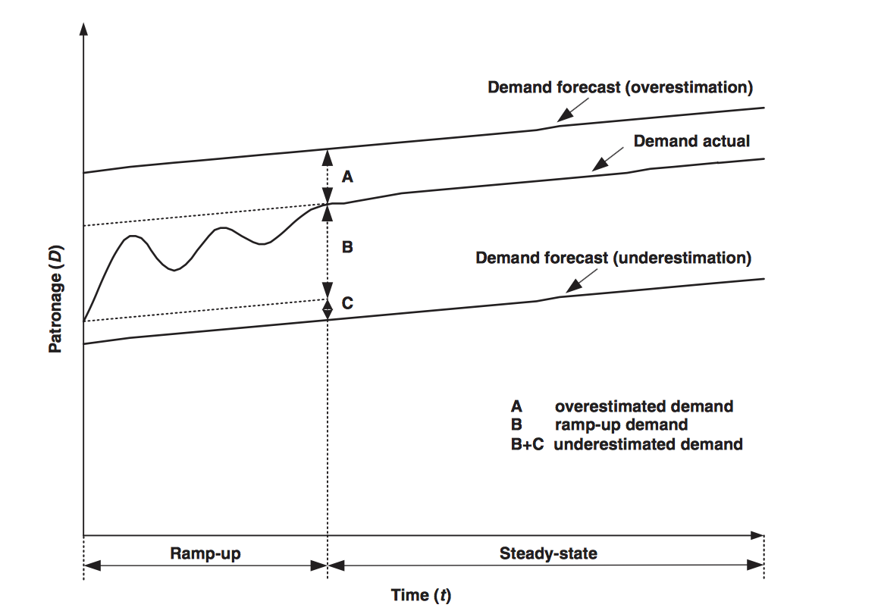

**Figure 1.** Ramp-up conceptual diagram

The initial amount of time refers to the ramp-up period, where ridership is variable. Following this time of variability, ridership levels off and there is a steady-state period. Ridership in this case is defined as “delay of demand building during the initial start-up periods of a new transport-service” (Chang et al. 2010, 84). This definition is repeated throughout the chapter and cited by various authors and transportation professionals.

### What causes ridership ramp-up?

Although the exact cause of ridership ramp-up behavior is not known, there are three common causations that Chang (Chang et al. 2010) identifies that most academics and planners agree on. The “learning curve” and time it takes people to learn about the new service is the one source of ridership ramp-up (Douglas 2005, 2). The time it takes people to adjust and change their travel behavior additionally influences the ramp-up period. This is correlated with the “learning curve” period of ramp-up, but is distinguishable in that it includes demand shifting. The final cause of ridership ramp-up can be attributed to operational troubles that plague transit systems at the beginning of transit projects (Chang et al. 2010). These sources are generally the causations of ridership ramp-up for transit projects, however this subject has not been explored to its full depth and there could be additional sources of ramp-up.

### How much error is explained by ridership ramp-up?

The amount of error caused by ridership ramp-up is typically described as small with respect to overall forecast error. In a response to his paper regarding high levels of inaccuracy in transit forecasting, Flyvbjerg (Flyvbjerg 2005) addresses the argument that ramp-up caused large error and argues that it takes a period of time before people effectively use a new transportation facility and subsequently change their travel behavior. Many experts agree measuring ridership after 2 to 5 years will produce results more similar to forecasted ridership values (Dehornoy 2015; Currie 2007) . However, Flyvbjerg (Flyvbjerg 2005) responded that opening year ridership observations are the more widely available than observations from subsequent years, so reliance on opening year observations is necessary to achieve a large sample of forecast accuracy measurements, and that ramp up could only explain a small portion of the very large forecast errors observed for many transportation projects. However, as ridership forecasts have improved in accuracy over time, the proportion of observed forecast error that can be attributed to unrealized ridership ramp up has likely increased (Voulgaris 2018).

Various agencies undergo performance evaluations to determine forecast accuracy and current performance, within the United States and internationally. Researchers analyzed the bus rapid transit (BRT) systems in Sydney, Brisbane, and Adelaide, Australia for infrastructure size, operations, and development characteristics. The performance metrics for the systems in Australia were measured in patronage, markets, operations, and overall urban development. Patronage (ridership) is compared to other markets throughout Australia and Asia, and the term ramp-up is mentioned when discussing the reasoning for a period of variation after a new project opening (Currie 2007). It is not uncommon to find the term “ramp-up” within transit system evaluation and literature regarding system evaluation.

Dehorony (Dehornoy 2015)discusses rail transit ridership shortfalls in traffic based-concessions in Europe. Dehornoy found that for most project comparisons, the first year of operation and the forecast are significantly different and concluded that ramp-up would be the primary source of this inaccuracy in the first few years after a project opens. Dehorony (Dehornoy 2015) argues that ramp-up periods are commonly underestimated by professionals and that ridership takes approximately five years to build up. This statement is made in reference to the Orlyval and Sydney Airport Rail Lines (ARL) since they experienced about a 5 year ramp-up period. This supports the claims made by Flyvbjerg and the Australia BRT, that ridership ramp-up takes a variable amount of time to commence. The actual number of years’ ranges depending on the author and type of ramp-up being addressed.

The concept of ramp-up is not limited to transit ridership, authors Kriger, Shiu, and Naylor focus on estimating toll road demand and revenue throughout the United States (Kriger and Shiu 2006). Toll road demand and forecasting is influenced by the idea of ramp-up which the authors define as the time for traffic to reach its full potential. This period is characterized by the authors as a period of unusually high traffic growth followed by annual growth figures that have (or appear to have) stabilized and that are closer to traffic patterns that have been observed on other, similar facilities. This reflects user unfamiliarity with a new system and its benefits, or a reluctance to pay new tolls. The authors found that ramp-up is typically project-specific and does not last more than five years. This number was found from a case study of 26 projects in the United States. However, they call for future research in this subject area. This is not atypical when researching ramp-up, it is widely accepted by professionals but not definitively determined. Many transportation planners and scholars suggest further research into the topic of user ramp-up, and not solely limited to transit ridership.

The common theme in transportation and transit literature is that ridership ramp-up exists, but has not been empirically studied. Therefore, evaluating the accuracy of transit ridership forecasts often fall short since it does not account for ramp-up. This idea is additionally supported by the Federal Transit Agency which requires that comparisons between forecasts and observations are taken after two years of service.

The Federal Transit Administration acknowledges and accounts for ridership ramp-up be requiring that performance measurement for projects funded by federal Capital Improvement Grants (New Starts projects) take place two years after project opening. In the absence of empirical evidence on the magnitude and timing of ridership ramp-up, it is difficult to determine whether this two-year delay in performance measurement is necessary or sufficient. This study builds upon the research summarized above to provide an empirical analysis that can support decisions about how to account for ridership ramp up in forecasting and performance evaluation for rail transit projects.

### How do different experts estimate ramp-up?

Not all experts agree on the duration and timeframe of transit ridership ramp-up. Table 1, below, shows the difference in opinion of experts and the amount of time they believe ramp-up takes.

**Table 2.** Ramp-up duration estimate by source

|  |  |  |
| --- | --- | --- |
| Source | Years of Ramp-up | Basis of estimate |
| FTA(“Federal Register, Volume 65 Issue 236 (Thursday, December 7, 2000)” n.d.) | 2 | Comments from transit industry stakeholders |
| Dehorony (Dehornoy 2015) | 5 | 2 rail lines |
| Kriger, Shiu, and Naylor (Kriger and Shiu 2006) | Under 5 | 26 toll road projects |

Table 2 , above, shows how different authors, scholars, and agencies have varying opinions on the length of time over which ramp-up occurs. These various durations have been derived by different methods of qualitative and quantitative analysis. The variation in amount of time may be dependent on the various methodologies used to analyze ramp-up. Most the studies that gave an amount of time for ramp-up used qualitative analysis of the actual ridership and when it appeared to steady state.

## What are other Factors that Influence Transit Ridership?

Different internal and external factors play a role with transit ridership, these include economic, social, cultural, environmental, and transit agency factors (Taylor and Camille N.Y. Fink, n.d.). When analyzing ridership ramp-up it is crucial to account for these additional factors. Financial crises, gas prices, population changes, area demographics, development, transit fares and frequencies, and other factors can influence the variability of ridership, along with ramp-up. This section will explore a few of the additional influences on ridership.

### External factors that influence ridership

Experts and researchers agree that there is a correlation between gas prices and transit ridership; researchers have discovered that typically as gas prices fall so does transit ridership (Damien Newton and Joe Linton 2015). In a study regarding gas price and transit ridership Lane (Lane, n.d.) found that there is a statistically significant amount ridership variation due to change in gas price. Lane found that in a time of constantly decreasing transit ridership, higher gas prices were associated with increasing ridership. However, the American Public Transit Association has made the claim that the gas/ridership relationship is not as prevalent in many cities throughout the U.S. where transit has expanded (Damien Newton and Joe Linton 2015). Although the relationship may be changing recently, studying the correlation between transit ridership and gas prices is crucial when analyzing trends in transit ridership.

Transit ridership is influenced by land use type, transit accessibility, income, and density. Charkraborty and Mishra (Chakraborty and Mishra, n.d.). found that these factors are statistically significant predictors for transit ridership in urban areas. Each of these factors will have a significant effect on ridership, and must be considered before determining if the variability in ridership in the years after a project opening is due to ramp-up or these outside factors. Assuming ridership ramp-up is occurring when outside factors are influencing the ridership would give skewed data and would not accurately portray the effects of ramp-up on a transit system.

Population and population characteristics provide large amounts of variation in transit ridership. Taylor, Millar, Iseki, and Fink (Taylor and Camille N.Y. Fink, n.d.) analyzed various characteristics that impact the amount of transit riders and discovered that population characteristics such as the percent of college students, recent immigrants, and democratic voters in the population (Taylor et al., n.d.). The majority of trips are taken by persons between 25 and 54 years old, over 55% of trips are taken by women, the majority of riders identify themselves are white, the primary occupational activity of public transportation is employment or work, the second being school, about 45% of riders have a vehicle available when deciding to make a transit trip, and a majority of riders own a private vehicle (John Neff and Larry Pham 2007). This profile reflects the breakdown of ridership and population characteristics of the riders, while this information does not inform the amount of ridership, there may be higher ridership in areas where these demographics are more prevalent.

Auto/Highway system characteristics such as percent carless households and non-transit/non-SOV trips, including commuting via carpools, walking, and biking may have effects on transit ridership. In Seattle, the SR 520 bridge was converted to a toll bridge and saw a 38% increase in transit ridership after tolled were put in place. Another example of a highway system changing and increasing transit is Atlanta’s I-85 express lanes, these express lanes support reliability and convenience of transit and although only 2% of the vehicles in the express lanes are transit, they carry 26% of the users of the express lanes. Households with percent zero vehicles are significantly and positively related to transit patronage (Taylor et al., n.d.,). Both highway systems and auto characteristics have impacts on transit ridership and transit systems performance.

Ridership is heavily influenced by the built-environment, this is a rich subject area of discussion with transportation and transit professionals. It is accepted that the built environment, such as a dense development, increases ridership since owning a car becomes more difficult in heavily populated areas and transit becomes a more convenient option of travel. Ewing and Cervero (Ewing and Cervero 2001) studied the elasticities of travel demand with respect to density, diversity, design, and regional accessibility and found that transportation outcomes are functions of demographics and the built environment. Not only does the built environment influence transit ridership, previously stated, but it also affects every aspect of transportation. Having a basis of knowledge for each factor that could influence not only transit ridership, but user behavior such as mode choice in different areas, will allow more in-depth research for ramp-up characteristics.

### Internal factors that influence ridership

While outside factors such as the built-environment, gas prices, auto user characteristics, population characteristics, and geographical characteristics have meaningful impacts on transit ridership, experts (Taylor and Camille N.Y. Fink, n.d.) find that the both fares and service frequency could account for at least a doubling (or halving) of transit use in a given urbanized area. Taylor and Fink (Taylor and Camille N.Y. Fink, n.d.) discuss how transit service frequency is shown to be more impactful to ridership than the fare and pricing variable. This includes transit fares, number of transit operators, and route density. Taylor et al. (Taylor and Camille N.Y. Fink, n.d.) finds that transit fares have a negative and significant relationship with transit ridership by utilizing regression modeling to determine statistical significance of each of these factors and transit ridership. Figure 2, below, models the different factors that may affect transit ridership. While the focus of this thesis is primarily on ridership ramp-up and how that affects transit ridership, each other factor that may impact ridership is crucial to be accounted for or acknowledged.

There are many potential factors that have been proven to significantly effect transit ridership. Figure 2, below, shows many potential factors that could influence ridership (Taylor et al., n.d.). These variables range from transit system characteristics to population characteristics.

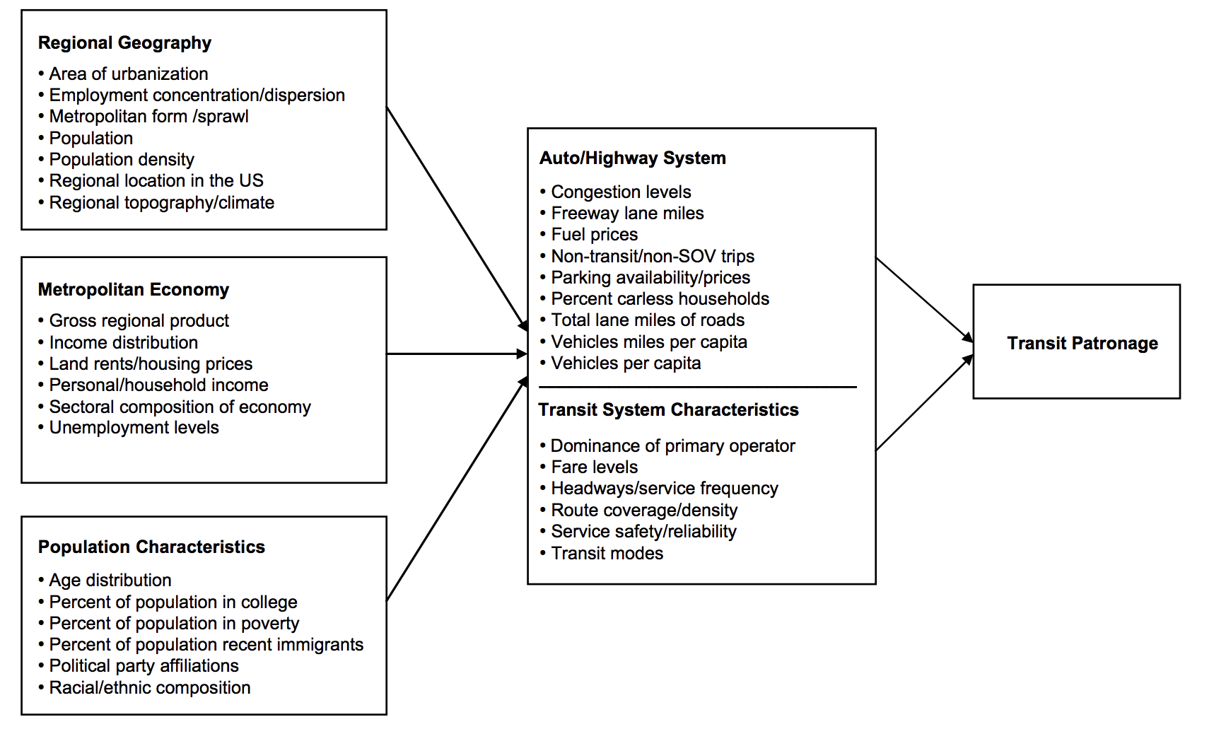

**Figure 2.** Conceptual model of factors influencing aggregate transit demand

Transit ridership is influenced by different characteristics and factors. While frequency and fare, the built-environment, auto/highway system characteristics, population characteristics, demographics, and gas prices are some of the primary influences in ridership discussed, there are many additional factors that affect transit ridership.

## Conclusion

Transit ridership ramp-up is mentioned frequently in studies regarding transit ridership, transit project evaluation, and transit ridership forecasting, however, most experts suggest that further research would benefit the breadth of knowledge on the subject. Previously mentioned factors have large impacts on ridership forecasts and they are highly inaccurate whether they account for ramp-up or not. This literature review will aid in the continued research of ridership ramp-up and the values behind it that will assist planners, engineers, and academics in developing more accurate forecasts and accounting for ramp-up as a factor that influences transit ridership.

# Methodology

The following chapter describes the procedures used when collecting and analyzing data for fixed-guideway transit ridership ramp-up. The methods of determining the sample data from the National Transit Database and the descriptive data analysis are included. The identification of the control variables and control variable analysis are included as well.

## Identifying Sample Data

Projects in the study sample were identified from the National Transit Database (NTD), which is maintained by the Federal Transit Administration (FTA) and contains data on financial and service characteristics of all public transit agencies in the United States that receive federal funding. The NTD contains historical data going back to 1991.

Fifty-five projects were included in the study sample based on three criteria:

1. The project is categorized as one of five rail transit modes: commuter rail (17 projects), heavy rail (8 projects), hybrid rail (one project), light rail (27 projects), or monorail (two projects).
2. The project resulted in an increase of at least five percent in directional route miles for its mode within the agency that operated it. The first full year after directional route miles increased is identified as the project’s opening year, or Year 0.
3. No further increases in directional route miles occurred on the project’s mode for the next four years. This is to isolate observed increases in ridership that are attributable to the identified project from those that result from subsequent projects.

Annual increases in ridership (measured in terms of unlinked passenger trips as reported in the NTD) were calculated for each of the first four years after the opening year (Years 1 through 4). For projects on systems that did not experience subsequent increases in directional route miles in Year 5, increases were calculated for Year 5 as well (this was the case for 44 out of 55 projects).

Six projects had ridership increases exceeding 100 percent between Year 0 and Year 1. Project descriptions for each of the outliers are included in section 3.4.2.

Table 3 lists the projects that are included in the study sample. The fourth column of Table 1 indicates the share of the transit system that the project represents. A value of 100 percent indicates a new project (for example, the first light rail line to open on a new light rail system), while a value of less than 100 percent represents an expansion of an existing system (for example, a project that doubled the directional route miles on a light rail system would have a value of 50 percent). Column 7 identifies if a project is an extension or a new line, there are 18 new projects and 37 extension projects within the sample.

**Table 3.** Projects included in study sample

|  |  |  |  |  |  |  |  |
| --- | --- | --- | --- | --- | --- | --- | --- |
| **Location** | **Mode** | **Agency** | **Project percent of system** | | **Opening year** | **Years included in sample** | **Ext./New Project** |
| Pittsburgh | Light Rail | Port Authority of Allegheny County | | 7% | 1993 | Years 1-5 | Extension |
| Boston | Light Rail | Massachusetts Bay Transportation Authority | | 7% | 1993 | Years 1-5 | Extension |
| Chicago | Heavy Rail | Chicago Transit Authority | | 13% | 1993 | Years 1-5 | Extension |
| San Carlos | Commuter Rail | Caltrain | | 39% | 1993 | Years 1-5 | Extension |
| Alexandria | Commuter Rail | Virginia Railway Express | | 8% | 1994 | Years 1-4 | Extension |
| Denver | Light Rail | Regional Transportation District | | 100% | 1994 | Years 1-5 | New Project |
| Seattle | Monorail | Seattle Center Monorail Transit | | 100% | 1994 | Years 1-5 | New Project |
| Baltimore | Heavy Rail | Maryland Transportation Authority | | 10% | 1995 | Years 1-5 | Extension |
| St. Louis | Light Rail | Metro Transit | | 100% | 1995 | Years 1-5 | New Project |
| Cleveland | Light Rail | Greater Cleveland Regional Transit Authority | | 13% | 1996 | Years 1-5 | Extension |
| Hartford | Commuter Rail | Shore Line East | | 35% | 1996 | Years 1-5 | Extension |
| Los Angeles | Light Rail | Los Angeles Metro | | 48% | 1996 | Years 1-5 | Extension |
| Oceanside | Commuter Rail | North County Transit District | | 100% | 1996 | Years 1-4 | New Project |
| Oakland | Heavy Rail | San Francisco Bay Area Rapid Transit | | 20% | 1997 | Years 1-5 | Extension |
| Pompano Beach | Commuter Rail | South Florida Regional Transportation Authority | | 7% | 1998 | Years 1-5 | Extension |
| Chesterton | Commuter Rail | Northern Indiana Commuter Transportation District | | 16% | 1998 | Years 1-5 | Extension |
| Baltimore | Light Rail | Maryland Transportation Authority | | 24% | 1998 | Years 1-5 | Extension |
| Sacramento | Light Rail | Sacramento Regional Transit District | | 11% | 1999 | Years 1-4 | Extension |
| Stockton | Commuter Rail | San Joaquin Regional Rail Commission | | 100% | 1999 | Years 1-5 | New Project |
| Los Angeles | Heavy Rail | Los Angeles Metro | | 39% | 2000 | Years 1-5 | Extension |
| Dallas | Light Rail | Dallas Area Rapid Transit | | 53% | 2000 | Years 1-5 | Extension |
| Seattle | Commuter Rail | Sound Transit | | 100% | 2000 | Years 1-5 | New Project |
| Jacksonville | Monorail | Jacksonville Transportation Authority | | 20% | 2001 | Years 1-5 | Extension |
| San Jose | Light Rail | Santa Clara Valley Transportation Authority | | 28% | 2001 | Years 1-4 | Extension |
| Miami | Heavy Rail | Miami-Dade Transit | | 6% | 2002 | Years 1-5 | Extension |
| Baltimore | Commuter Rail | Maryland Transportation Authority | | 7% | 2002 | Years 1-5 | Extension |
| Salt Lake City | Light Rail | Utah Transit Authority | | 8% | 2003 | Years 1-5 | Extension |
| Oakland | Heavy Rail | San Francisco Bay Area Rapid Transit | | 9% | 2003 | Years 1-5 | Extension |
| Jersey City | Heavy Rail | Port Authority Trans-Hudson | | 13% | 2003 | Years 1-5 | Extension |
| Dallas | Light Rail | Dallas Area Rapid Transit | | 18% | 2003 | Years 1-5 | Extension |
| Seattle | Light Rail | Sound Transit | | 100% | 2003 | Years 1-5 | New Project |
| Los Angeles | Light Rail | Los Angeles Metro | | 25% | 2004 | Years 1-5 | Extension |
| Minneapolis | Light Rail | Metro Transit | | 100% | 2004 | Years 2-5 | New Project |
| Houston | Light Rail | Metropolitan Transit Authority of Harris County | | 100% | 2004 | Years 1-5 | New Project |
| Pittsburgh | Light Rail | Port Authority of Allegheny County | | 23% | 2005 | Years 1-5 | Extension |
| Seattle | Commuter Rail | Sound Transit | | 46% | 2005 | Years 1-5 | Extension |
| San Juan, PR | Heavy Rail | Tren Urbano | | 100% | 2005 | Years 1-5 | New Project |
| Santa Clara | Light Rail | Santa Clara Valley Transportation Authority | | 13% | 2006 | Years 1-5 | Extension |
| Denver | Light Rail | Regional Transportation District | | 55% | 2006 | Years 1-5 | Extension |
| San Francisco | Light Rail | San Francisco Municipal Railway | | 12% | 2007 | Years 1-5 | Extension |
| St. Louis | Light Rail | MetroLink | | 17% | 2007 | Years 1-5 | Extension |
| Sacramento | Light Rail | Sacramento Regional Transit District | | 21% | 2007 | Years 1-5 | Extension |
| Portland, ME | Commuter Rail | Northern New England Passenger Rail Authority | | 44% | 2007 | Years 1-4 | Extension |
| San Diego | Light Rail | San Diego Metropolitan Transit System | | 100% | 2007 | Years 1-5 | New Project |
| Salt Lake City | Light Rail | Utah Transit Authority | | 5% | 2008 | Years 1-4 | Extension |
| Boston | Commuter Rail | Massachusetts Bay Transportation Authority | | 100% | 2008 | Years 1-5 | New Project |
| Albuquerque | Commuter Rail | New Mexico Department of Transportation | | 100% | 2009 | Years 1-5 | New Project |
| Phoenix | Light Rail | Valley Metro Transit System | | 100% | 2009 | Years 1-5 | New Project |
| Portland, OR | Light Rail | TriMet | | 15% | 2010 | Years 1-5 | Extension |
| Dallas | Commuter Rail | Dallas Area Rapid Transit | | 60% | 2010 | Years 1-5 | Extension |
| Kenosha, WI | Commuter Rail | Metra | | 46% | 2011 | Years 1-4 | Extension |
| Newark | Commuter Rail | New Jersey Transit | | 100% | 2011 | Years 1-4 | New Project |
| Austin | Commuter Rail | Capital Metropolitan Transportation Authority | | 100% | 2011 | Years 1-4 | New Project |
| Portland, OR | Hybrid Rail | TriMet | | 100% | 2011 | Years 1-4 | New Project |
| Oceanside | Light Rail | North County Transit District | | 100% | 2011 | Years 1-4 | New Project |

### Opening year definition

During the analysis, I made various choices to define the years of the projects . Year 0 of a project is considered the project’s first full opening year. Therefore, the first year of data I analyze is the percent change in ridership from Year 0 (opening year) and year 1. Percent change in ridership for Year 1 in my analysis will indicate this. Note that if a project opened in December of 2000 the first full year of opening is considered 2001. This means that there could be up to 11 months of time for a project to have changes in ridership that are unaccounted for.

## Descriptive Data Analysis Methodology

The descriptive data analysis primarily focused on the data from the National Transit Database. I analyzed the 55 samples from the NTD by comparing five to six years of Unlinked Passenger Trip (UPT) data. I calculated the percent change from the first year after the project opening to each year after. Additionally, I calculated percent change from between each year over the five or six years after project opening. Equation 1, below, displays the percent change equation used in the descriptive data analysis.

***Equation 1.*** *Percent change equation used in descriptive data analysis*

Y2 = Unlinked Passenger Trips in Year 2

Y1= Unlinked Passenger Trips in Year 1

After calculating the percent change from the first year of data and between subsequent years I determined the average and standard deviation for the total project sample. Additionally, I sorted the data by mode (light rail, heavy rail, commuter rail, etc.), new line versus extension, and by year of opening. I measured the average and standard deviations of each of the sorted data samples. I sorted data to determine if there was a trend by mode, new line or extension, or by year of opening to determine if there are trends specific to the different subareas. Results for the descriptive data analysis will follow in Chapter 4 Results.

## Qualitative Data Sample Selection

When looking at the raw data collected from the NTD, some projects had significant increases or decreases in ridership, missing data, or other anomalies. These projects were either determined to be outliers and excluded from the data sample or mentioned later in this section.

Qualitative data analysis was done by visually looking through the raw Unlinked Passenger Trip data, the calculated percent change, and graphs created to analyze the sorted percent change. Visually scanning the data displayed some clear outliers and anomalies within the sample data.

During the data collection process some data had significant changes in ridership between years. I analyzed the projects quantitatively and qualitatively to justify reasoning for unpredicted data and eliminated data which appeared erroneous or had uncontrolled outside variables influencing the ridership. The following section explains the reasoning for not including certain projects or why some projects have higher or lower values than the average.

### Excluded Projects

The following projects have all years of ridership excluded from the data, whether due to unreliable or missing data. Although this data met the previously stated conditions of my analysis, appropriate mode and a change in DRM above 5% of the total system DRM. Most of the projects described below did not have reliable annual data from the agency reported to the NTD.

The following projects are excluded due to lack of published data in the NTD. I excluded the Southern California Regional Rail Authority dba: Metrolink Commuter Rail from the data sample since it only had ridership information for one year. The Charlotte Area Transit System (CATS) Light rail was excluded from the data sample because one year of ridership information was not reported to the NTD. The Tri-Met Streetcar, Tri-County Metropolitan Transportation District of Oregon, was excluded from the data since the agency did not collect a consecutive 5 years of ridership data. The West Virginia University - Morgantown Personal Rapid Transit Monorail are excluded from the data of study since it is a private monorail and does not publish ridership data to the National Transit Database. While each of these projects met the condition for DRM and mode, they did not provide enough ridership data to include in my analysis.

The Greater Dayton Regional Transit Authority (GDRTA) Trolley-Bus Data was determined to have an error due to the data entries. In 2001; there is an approximately 900% decrease in ridership from 2000 to 2001. Subsequently, there is a 900% increase from 2001 to 2002. This could be an inaccuracy in measurement or false-reporting to the NTD by the GDRTA. Therefore, the ridership data was excluded from the data of study since the reliability of the data is unclear.

The NTD classifies various modes of transportation as fixed guideway, however I did not include all forms of fixed guideway for various reasons. Aerial tramway was not included since it is used in special circumstances and there are very few systems within the United States. Ferry boat was not included due to the significantly different nature of the system from rail and other fixed-guideway modes. Bus Rapid Transit (BRT) was not included since many BRT routes are modified on an annual or consistent basis and the DRM changes frequently. Although BRTs can function similar to a light rail, the variation in routes and length of routes does not make it applicable for this study. Table 3, below, displays the different fixed-guideway transit modes in the NTD and which are included or excluded in the study.

**Table 4.** National Transit Database fixed-guideway modes included in analysis

|  |  |
| --- | --- |
| Mode Type | Included/Excluded |
| Heavy Rail | Included |
| Light Rail | Included |
| Trolley-Bus | Excluded |
| Hybrid Rail | Included |
| Commuter Rail | Included |
| Bus Rapid Transit (BRT) | Excluded |
| Monorail | Included |
| Aerial Tramway | Excluded |
| Ferry Boat | Excluded |
| Inclined Plane | Excluded |
| Cable Car | Excluded |

The included fixed-guideway modes included in the analysis are limited to rail transit projects. Since other modes had few applicable years of UPT and DRM they could not be included in the sample. Further study would allow for additional fixed-guideway modes to be included in an analysis of ramp-up behavior.

### First year after opening outliers

The following projects have the first full year of ridership data excluded from the analysis due to the dramatic increase in ridership between year 0 and year 1. This section describes each project in depth and potential reasons why ridership would climb so rapidly. These cases may represent extreme ramp-up scenarios but do not have a large effect on the results when included in the analysis.

**Figure 3.** Ridership for Sound Transit light rail after first full year of opening

The Seattle Link light rail service opened new service in Tacoma, Washington in 2003. The system operated as a fare free service since its opening and remains in fare free service in 2018. The corridor is approximately 1.6-miles through downtown Tacoma, which is south of Seattle, Washington. The large increase from the first full year of opening and the year after may be due to non-revenue service and marketing before the project opening. The rail corridor also connects a large parking garage to the Tacoma Dome. The Tacoma Dome hosted major concerts in the year after opening which may have impacted the large increase in ridership (“Link Light Rail | Getting Around Downtown Tacoma for Free” 2018). Figure 3 shows the trends in ridership from the first year of opening.

**Figure 4.** Ridership and employment in computer systems design and related services for Alamont Corridor Express after first full year of opening

The Stockton commuter rail (Alamont Corridor Express) opened new service in 1999 with high ridership initially after the first full year of the project opening due to an increase in the technology and computer industry in Silicon Valley. This was followed by a large drop off due to the dot-com crash between 2001 and 2002 (“History of ACE - ACE | Altamont Corridor Express” n.d.). Figure 4, shows the trend in ridership for the years after the project opening and employment in computer systems design and related services from the BLS. The trend in ridership follows a similar trend in employment in the tech industry.

**Figure 5.** Ridership for MBTA light rail after first full year of opening

The Massachusetts Bay Transportation Authority opened its Worchester extension light rail line in 1993 with a ridership trend of high amounts of growth followed by a drop-off in ridership the year after. There is a large increase from the first full year of opening to the year after. A possible explanation for the increase in ridership could be the line had fare free service briefly in 1995 due to service delays for vehicles to access to the maintenance facilities (July 5 and 2006 n.d.).

**Figure 6.** Ridership for Minneapolis Metro Rail after first full year of opening

Minneapolis Metro Rail opened the Metro Blue Line in 2004 in Minneapolis, Minnesota. From Figure 6, above, ridership can be seen steadily growing over time, with a large increase between the first full year of opening and the year after. This could potentially be due to the introduction of smart cards in 2006 to the system and the ease of travel with this new method (“METRO Blue Line Facts - Metropolitan Council” n.d.). The introduction of smart cards in various systems has been shown to increase transit ridership (Allison C. Yoh et al. 2006). In addition to the new smart cards, the Metro Blue Line also increased service in 2006 by adding more train vehicles with leftover funds from construction.

**Figure 7.** Ridership for Seattle Sounder commuter rail after first full year of opening

The Seattle Sounder North line commuter rail opened in 2003. Later the following year Sound Transit added additional services to Seahawks games in the evening which significantly increased ridership (Beth Drupal 2015). As popularity of the route increased, additional trains were added which further increased the amount of ridership. Figure 7 shows the dramatic increases in ridership between the year of opening and the year after.

**Figure 8.** Ridership for Tren Urbano in Puerto Rico after first full year of opening

The Tren Urbano was opened in San Juan, Puerto Rico in 2004. The rail service operated and began fare free service on weekends until late 2005 to combated opening year low ridership. Total fare free service then expanded to weekdays in 2006 to continue to fight low ridership after the opening year (Lewis-Workman 2007). This significantly increased ridership in the first year after project opening. Figure 8, above, displays the trends in ridership over the first few years after project opening for Tren Urbano.

Each of these projects have specific circumstances unique to themselves that could not be specifically accounted for or controlled in the analysis.

## Identifying Control Variables

There are different outside influences on national transit ridership, other than ramp-up. This includes gas prices, car ownership, population, population characteristics, unemployment rates, agency size, age demographics, climate in the area, transit service coverage, and others as discussed in the literature review (Taylor et al., n.d.). I collected data for four different control variables; population by city, unemployment by city, gas prices by state, and income by state. All control variables are percent changes of each of the values between subsequent years. The percent change is calculated from Equation 1, shown in section 3.2 Descriptive Data Analysis. All control variables are included to ensure that the data shows if significant changes in the control variable over time have effects on the percent change in ridership, or if the percent change in ridership can be attributed to ramp-up.

### Gas Price

Gas price was considered in my controlled data analysis since transit professionals agree a “significant amount of ridership fluctuation is due to changes in gasoline prices” (Lane, n.d.). I collected gas prices from the United States Energy Information Administration (EIA) by year and state from 1991 to 2015. The EIA only provides an average gas price by state. This introduces error since gas prices in one area of a state may vary from another. However, variation in gas price is also common throughout a single year, so an annual average by state is the closest control variable that can be collected for the analysis.

### Population

Population has a significant impact on transit ridership; higher population indicates there will be higher transit ridership. In Taylor et alt.’s article they found, “population density and the proportion of zero vehicle households is positively associated with increased per capita levels of transit service” (Taylor et al., n.d.) and increased transit service indicates increased transit ridership. I collected population data from the United States Census from 1991 to 2015 by city or “place”. Originally, I planned on using the urbanized area (UZA), however the definition of how to determine the size of the UZA changed from the 1990 census to the 2000 census so the populations would not be of a consistent area. Population was considered rather than population density since the area would not stay the same over time and I was focused on the change from year to year of the population which would be the same if it was population density. While each of those would be significant since many transit systems span multiple cities and UZAs and MSAs would account for that, the definition of UZA and MSA changes, as mentioned previously, so population by city was chosen as the most consistent and easily collected control variable.

### Unemployment Rate

Unemployment rate is a measure of the economy in an area of study. Transit use is highly sensitive to employment: Taylor and Fink (Taylor and Camille N.Y. Fink, n.d.) find that employment levels are common demographic variables used in casual analyses of transit use and ridership. In many studies, experts have found that employment has a larger affect than population (Taylor et al., n.d.). Since the 1920s unemployment rates have been correlated with either increased or decreased transit use. I collected unemployment rate data by year and city the project is, located in the Bureau of labor statistics. I chose city since I found it was the most consistent data between 1991 and 2015, and has a reliable area. State and county is typically too large and many transit systems do not reach an area that large. UZA and MSA are not chosen as the area since the area of these changed between the 1990 and 2000 census and different.

### Agency Operating Budget

The agency operating budget is the amount of money that the transit agency spends on operations and maintenance of their transit system. A higher agency operating budget could indicate higher ridership in the first few years of a project. While having a high agency operating budget does not typically have a correlation with ridership, it is a way to analyze the amount an agency spends on marketing. However, agency operating budget does account for more than marketing, it includes the amount spent on transit vehicles, maintenance, operations, salaries, marketing, and more. Various studies have found that marketing for transit projects does increase transit ridership (Taylor and Camille N.Y. Fink, n.d.; Carole Abel Lewis 2012). I collected the amount the agency spent the year before the opening of each project. The operating budget from the year prior to project opening was collected since it would reflect the agency size and value before the new extension or line would be opened. Agency operating budget was collected from the year before the project opening, since it indicates how large the agency is immediately before the new project opened.

### Percent Growth of System

I measured the percent growth of the system from the directional route miles before the project opening and after the project opening. Projects that are new lines are considered 100% growth since the DRM started at zero. I predicted that extensions that are smaller, for example less than 20%, can be expected to not see a large increase in overall ridership for the system. However, systems that are new and have 100% growth will have significant increases in ridership. The percent growth will have significant implications on ridership ramp-up for each system. Additionally, differentiating new projects and extension projects will allow for a separate analysis on ramp-up behavior for each type of project. Since extension projects and new projects may vary in characteristics and the potential new populations they may reach, it is crucial to identify and evaluate transit ridership patterns for each.

### Income

Median household income by state is an additional control variable included in analysis. All income data was gathered from the United States Census American Community Survey. Therefore, there is a margin of error for each of the income estimates since the ACS utilizes smaller sample sizes of populations. Median household income by state was chosen due to the accessibility of the data from 1991 to 2015. In Taylor and Fink’s paper regarding different factors that influence transit ridership they explain “economic factors, such as unemployment levels, CDB employment levels, and income levels explain a substantial portion of transit use” (Taylor and Camille N.Y. Fink, n.d., 13). Median household income rising or dropping should inform some changes in ridership during my analysis and will be accounted for separately from potential ridership ramp-up.

### Unidentified Control Variables

Many variables identified in the literature review are not included in the control variable sample. Table 4, below, identifies the control variables included or excluded in the controlled analysis.

**Table 5.** Control variables included or excluded in analysis

|  |  |
| --- | --- |
| Variable | Included/Excluded |
| Percent Growth of System | Excluded |
| Agency Operating Budget | Excluded |
| Population | Included |
| Unemployment Rate | Included |
| Gas Price | Included |
| Land-use | Excluded |
| Income | Included |
| Demographics | Excluded |
| Auto/Highway Characteristics | Excluded |
| Car Ownership | Excluded |
| Transit Service | Excluded |
| Transit Fare | Excluded |

Some variables, shown above, were not included in the analysis due to the inconsistency of reliable data collection. Many sources do not have data that is city, UZA, or MSA-specific or that is recorded on an annual-basis. Further limitations of the control variables is discussed later in this thesis. While including more control variables would provide more breadth on the analysis and provide different results, I was unable to collect reliable amounts of data and this would be something to consider in further analysis of ramp-up. Additionally, including too many controls could decrease the sample size so that there would be no way to find statistical significance in the results.

## Regression Analysis Methodology

Ramp-up alone cannot explain changes in ridership in the initial years after a project opens. Many external factors including gas prices, car ownership rates, population densities, total service area populations, unemployment rates, and service-area demographics have been shown to contribute to changes in ridership (Taylor et al., n.d.; Lane, n.d.; Chen, Varley, and Chen 2011). In this analysis, I control for four variables with well-documented influences on transit ridership: change in gas prices, changes in population, changes in income, and changes in unemployment. State-wide average gas prices were collected from the United States Energy Information Administration (“United States - SEDS - U.S. Energy Information Administration (EIA)” 2018). Populations of the central cities served each transit project were based on estimates from the United States Census Bureau, interpolating between decennial census years as necessary. Unemployment rates in the central cities served by each transit project were obtained from the United States Bureau of Labor Statistics.

### Regression Model

Three regression models were used to analyze the percent change in ridership controlled for outside factors. The following section describes the various model types used in the analysis.

A fixed-effects regression model was used to identify the changes in transit ridership in the initial years after project opening that is not explained by changes in gas prices, population, or unemployment. The form of the regression model is shown below:

${∆R=\sum_{n=1}^{5}{\left({β_{0}}_{n}Y_{n}\right)}+β}_{gas}∆_{gas}+β_{pop}∆_{pop}+β_{unemp}∆_{unemp}+β_{income}∆_{income}$ (1)

Where: *R* = Percent change in ridership,

*gas* = Percent change in gas price,

*pop* = Percent change in population,

 *unemp* = Percent change in unemployment rate,

  *income*= Percent change in income,

*Yn =* Indicator for whether the above changes were in the *nth* year after opening,

${β_{0}}_{n}$*=* Independent percent change ridership in *nth* year after opening,

**gas = Estimated elasticity of ridership with respect to gas price,

**pop = Estimated elasticity of ridership with respect to population,

**unemp = Estimated elasticity of ridership with respect to unemployment rate, and

**income = Estimated elasticity of ridership with respect to income.

The models includes an observation for each year of each project included in the sample. Year-over-year changes for a particular project are not independent, so clustered standard errors were used to determine the significance of coefficient estimates, using the “multiwaycov” package for R statistical software (Graham, Arai, and Hagströmer 2016).

This model includes an additional control for whether a project is new or an extension. The form of the regression model is shown below:

${∆R=\sum_{n=1}^{5}{\left({β_{0}}_{n}Y_{n}\right)}+β}_{gas}∆_{gas}+β_{pop}∆_{pop}+β_{unemp}∆_{unemp}+β_{income}∆_{income+}β_{new}new$ (2)

Where: *new =* Binary indicator variable for new projects, and

**new = Additional percent change in ridership per year for new projects.

Model 2 accounts for new projects through the binary indicator variable *new.* The variable is binary therefore, a new project is identified as a “1” and an extension is a “0”. **new will account for any additional percent change in ridership per year for a new project. If extension projects and new projects have differing behaviors the coefficient variable will account for the additional percent change in ridership.

Model 3 includes an additional interaction variable to account for new projects and the year of comparison. The form of the regression model is shown below:

${∆R=\sum_{n=1}^{5}{\left({β_{1}}_{n}Y_{n}*new\right) }+\sum_{n=1}^{5}{\left({β_{0}}_{n}Y_{n}\right)}+β}_{gas}∆_{gas}+β_{pop}∆_{pop}+β_{unemp}∆_{unemp}+β_{income}∆_{income}$ (3)

Where: *new =* Binary indicator variable for new projects, and

${β_{1}}_{n}$ = Additional percent change in ridership in *nth* year after opening for new projects.

Model form 3 includes a binary indicator variable, similar to model 2, that represents a new project as a “1” and extension project as a “0”. ${β_{1}}_{n}$ accounts for additional percent change in ridership in the nth year after project opening for a new year. This model accounts for the interaction between the year and if a project is new and how each year for a new project will have a different percent change in ridership.

Since the purpose of the models is to estimate changes in ridership based on changes in independent variables, variables that do not change from year to year (such as mode and operating budget) are not included. The model assumes that the ridership elasticities with respect to gas price, population, income, and unemployment do not change from year to year, but that the ridership increases that are not attributable those elasticities do vary from year to year. The theory of ridership ramp-up would suggest that ${β_{0}}_{n}$ would be highest for Year 1, and would decrease in each of the subsequent years. Additionally, I expect that ${β_{1}}_{n}$ would be the highest for Year 1 and new projects since new projects are expected to have higher ramp-up than extension projects.

### Clustered standard error analysis

In a typical regression analysis, there are various assumptions made during the process; one being that all variables are independent of each other (no correlation). However, in an analysis of ridership ramp-up, it is not practical to claim that ridership, gas price, income, population, unemployment, and each year is not correlated (i.e. the change in ridership in year 2 can be dependent on the change in ridership in year one). Therefore, a linear regression with clustered standard error was used in the analysis of my data. In this type of analysis I consider statistical inference for regression when data are grouped into clusters, with regression model errors independent across clusters but correlated within clusters (Colin Cameron and Miller 2015). Essentially, this type of regression model allows for the variables to be dependent.

### Statistical Significance

Statistical significance indicates that a result from testing or experimenting is not likely to occur randomly or by change, but is instead likely to be attributable to a specific cause (Colin Cameron and Miller 2015). During my analysis, I determined that a confidence interval of 95% would indicate statistical significance for different control variables. For the output, this means that any probabilities (P-values) that are under 0.05 are statistically significant, while those that are above 0.05 are not. Verifying that data is statistically significant allows us to have confidence in the results and to ensure they are not by random chance.

## Conclusions of methodology

Each of the 55 sample projects are unique to each other by year, location, type of project, and outside characteristics . The quantitative analysis of the raw data determines the overall behavior of the projects, while the adjusted analysis of the data from the control variables ensures outside factors are not influencing the presence of ramp-up. The qualitative analysis is equally important, since each project has unique characteristics that could influence ridership and ridership ramp-up.

# Results

The following chapter describes the results from the analysis of percent change in ridership and subsequent control variables. This chapter examines the results from the descriptive analysis of ridership, this includes averages of the data collected from the NTD and different classifications of the data. Additionally, this chapter reviews the results from the controlled analysis of ridership ramp-up. All results are analyzed for statistical significance and a discussion is included to analyze the meaning of the results.

## Descriptive Analysis Results

All data was collected from average annual unlinked passenger-trip data in the National Transit Database (NTD). The percent change between ridership in opening year and year 1 is calculated using equation 1. The data was not controlled for outside factors such as gas prices, population, income, unemployment rate, and percent of growth for the project. While these variables may have an impact on the results, it will be discussed later in the controlled data results.

### Findings from descriptive data analysis

For the descriptive analysis of the data I averaged the percent ridership growth since the prior year for all the projects, excluding outliers. Additionally, I measured the standard deviation of ridership change since the prior year and the percent of observations with increased ridership since the prior year. Table 5, below, displays the results of the descriptive analysis of the data. Note that the first year since opening and the fifth year since opening have 49 and 44 observations, respectively. The first year excludes 6 outliers, while the fifth year does not have observations for some projects due to changes in DRM.

**Table 6.** Characteristics of ridership growth by number of years since project opening

|  |  |  |  |  |  |
| --- | --- | --- | --- | --- | --- |
| **Year after project opening** | | **Number of observations** | **Average percent ridership growth since prior year** | **Standard deviation of ridership change since prior year** | **Percent of observations with increased ridership since prior year** |
| First | 55 | | 10% | 19% | 69% |
| Second | 55 | | 5% | 18% | 67% |
| Third | 55 | | 2% | 10% | 58% |
| Fourth | 55 | | 3% | 9% | 67% |
| Fifth | 44 | | 1% | 10% | 55% |

Most the observations increased in ridership over time, however this value stayed consistently between 55-69% with no obvious trend. I would expect the percent observations with increased ridership since the prior year to continue a trend up. If ramp-up exists, I would expect the average percent growth since the prior year to decrease over time. From Table 1 it shows that indeed the average percent ridership growth since the previous year does decrease over time. However, the standard deviation remains around 9-10% for the third, fourth, and fifth years, which would be expected to decrease over time as well. I expected the standard deviation to decrease since ramp-up estimates that variability in ridership will decrease with time, as shown in Figure 9, below.

Figure 9 displays the results graphically, below. The graph shows the decreasing trend of the average percent growth of ridership since the previous year. The standard deviations are shown as error bars, which remain about the same size for each year.

**Figure 9.** Average percent growth of ridership since previous year

Figure 9 shows the percent ridership growth since the prior year decreasing over time. The first year after project opening is around 10 percent ridership growth, with a range of around -10 percent to 29 percent. The fifth year after project opening is around 1 to 2 percent with a smaller standard error. This trend matches predictions that over time ridership variability decreases and that the first few years after opening have the most variability in ridership.

**Figure 10**. Percent of observations with increased ridership growth since prior year

Figure 10 above displays the percent of observations with increased ridership since the prior year. The number of projects with an increase in ridership decreases over time, however the range is around 55 to 69 percent for each of the years.



**Figure 11**. Ramp-up conceptual diagram

Comparing the conceptual diagram of ramp-up to the actual data supports this idea that the initial years a project is open there is more variability and later the project will reach a steady state in patronage. This is reflected by the decreasing standard deviation over time in Figure 11. The conceptual diagram is provided by Chang, and further explained in the literature review.

The following figures display the percent change in ridership for each of the years after project opening. Each of the figures displays the spread of the percent change ranging from -100 to 100 percent.

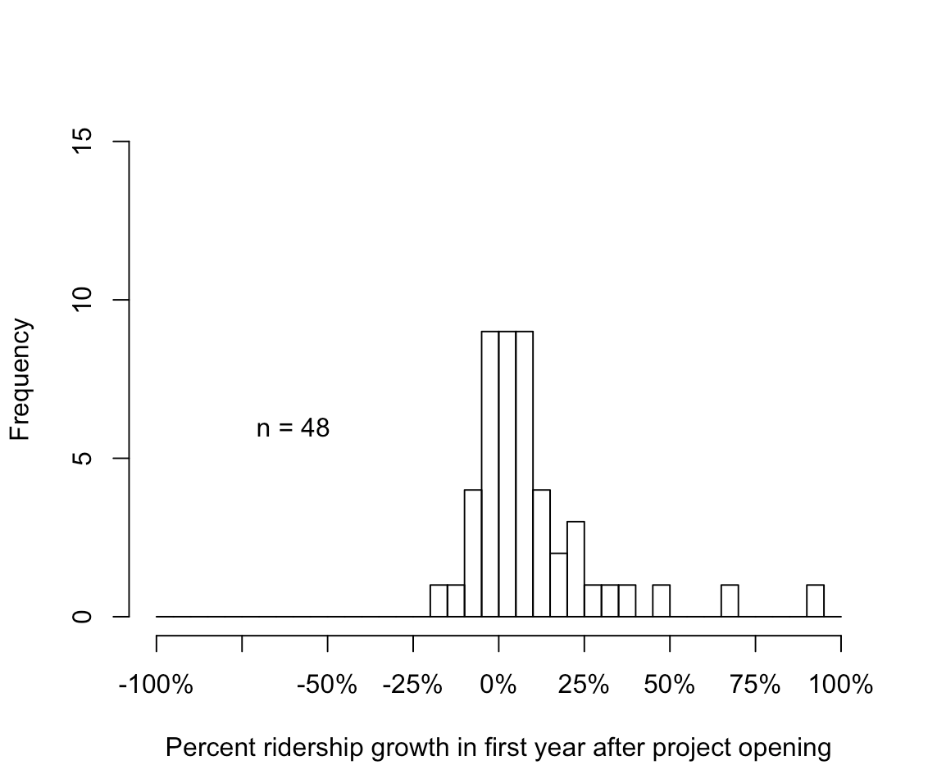

**Figure 12.** Percent ridership growth in first year after project opening

The percent change in the first year after the project opening has 48 sample projects since some outliers with over 100% growth are excluded from the sample size. -The distribution of the percent ridership growth in the first year is generally clustered around 0%, but there is a long tail in the positive direction. It is important to note that there is also a large frequency of projects that have negative percent ridership growth in the first year after project opening. This indicates that the percent ridership growth in the first year after project opening is highly variable.



**Figure 13.** Percent growth in second year after project opening

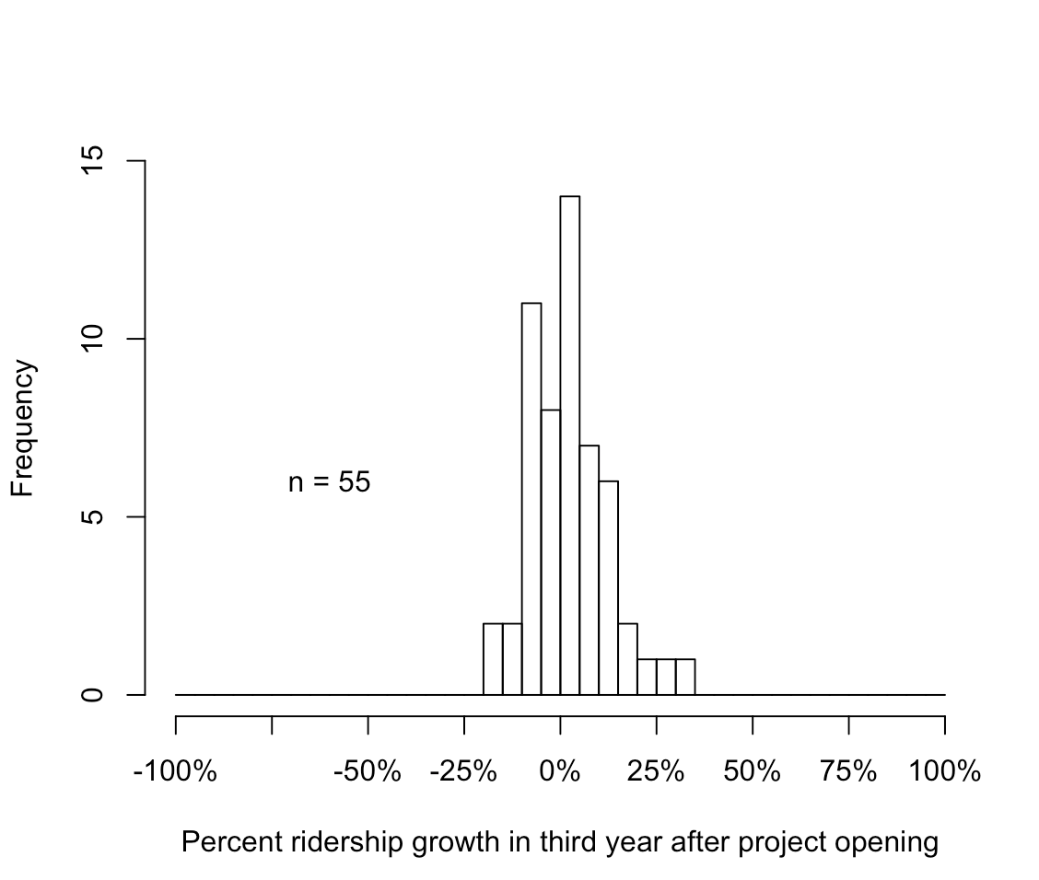

**Figure 14.** Percent ridership growth in third year after project opening

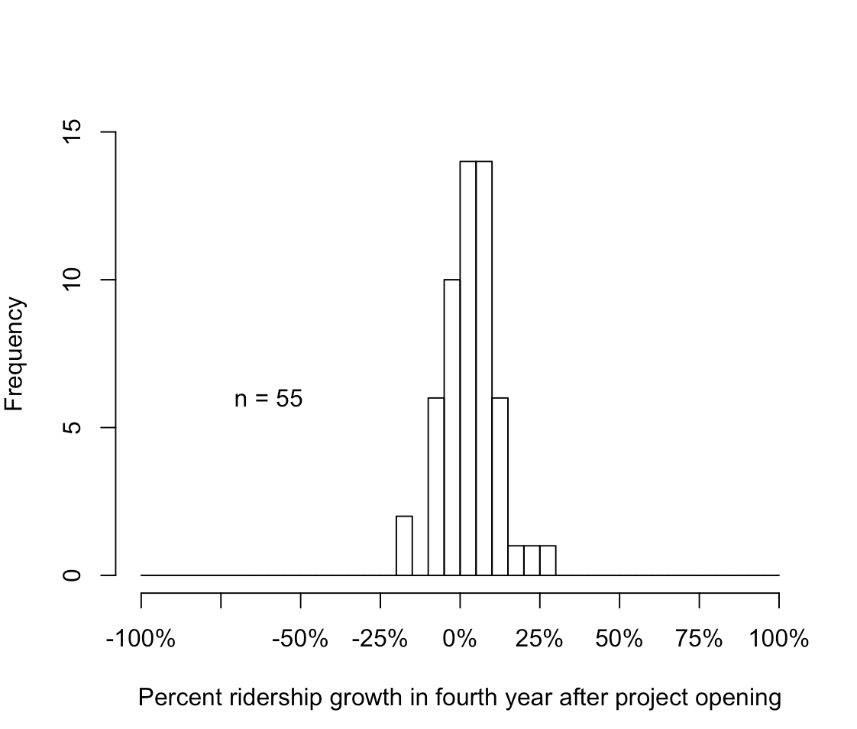

**Figure 15.** Percent ridership growth in fourth year after project opening

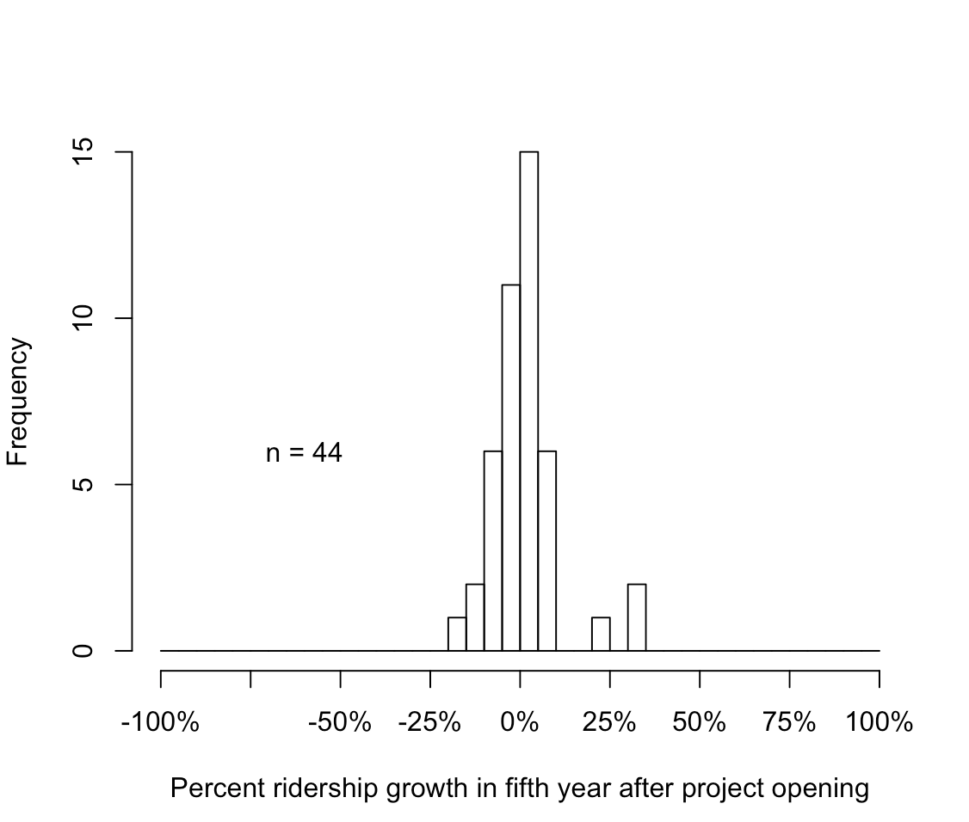

**Figure 16.** Percent ridership growth in fifth year after project opening

Figures 12 through 16 display the percent ridership growth in the second, third, fourth, and fifth years, respectively. As time goes on the percent ridership growth clusters more around 0%. This follows the pattern expected in ridership that over time there is less variability in the percent ridership growth. Ridership becomes more consistent for each project over time and the variation in ridership growth between projects also decreases.

### Data sorting

In both the controlled and descriptive analysis dividing the sample into subsections allows for a better understanding of the data and potential trends based on categories. For the descriptive analysis I sorted projects by mode and by new project/extension.

#### Sorting by mode

Sorting the raw data by mode; light rail, heavy rail, commuter rail, hybrid rail, and monorail allowed me to identify any modes that are distinguishable and have their own separate ridership trends or ramp-up characteristics. Each mode is significantly different in the type of use it has and the typical ridership. For example some monorails are used for tourism rather than typical daily commuters, like commuter rail. Sorting by mode is a simple way to identify if any modes are significantly skewing the data. The following figures show the percent change in ridership sorted by transit mode, as per the NTD.

**Figure 17.** Percent change ridership since prior year by mode (LR, CR, HR)

**Figure 18.** Percent change in ridership since prior year for different mode (HR, MR)

Figures 17 and 18 display the percent change in ridership since the prior year, by mode. Figure 17 shows the modes with larger samples, light rail, commuter rail, and heavy rail. These modes follow a similar trend with high percent change in ridership the first year after opening, and decreasing percent change in ridership over time. This follows the idea of ramp-up and that variability of ridership decreases over time. Figure 18 shows the modes with a smaller sample size, hybrid rail and monorail. Note that monorail does not have data for the fifth year after project opening. The percent change in ridership since the prior year for each year significantly varies for these modes. This could be due to a limited sample size and more project-specific characteristics affecting ridership. However, I find that over time the percent change in ridership decreases over time for each mode.

#### Sorting by new project or extension

I also sorted the descriptive NTD data by new projects, that is projects that have no previous directional route miles and project extensions, which are projects that are extending an already existing system with existing directional route miles. Data was sorted this way to determine if a new project or an extension project would have different percent change in ridership for each year after opening since ridership characteristics may be dependent on the age of the system and a new project could have ridership patterns that vary from ridership patterns for an extension project.

**Figure 19.** Percent change year to year sorted by new line or extension

Figure 19 shows the percent change in ridership since the prior year sorted by new project or extension. The chart displays that new projects have a higher percent change since the prior year compared to extension projects. This indicates that new projects see a larger jump in first year ridership after project opening than extension projects. This is logical since extensions may be small and not reach a large amount of people or not be as well utilized in their respective communities. However, since this is a descriptive data analysis this does not account for any outside factors or variables that could influence ridership behaviors or patters for each of the projects and the years. No conclusions on ramp-up can be drawn from this data, however it is clear that new project data shows a significant increase in year 1.

### Conclusions from descriptive data analysis

Ridership data collected from the NTD and analyzed in this section reveals that the variability in transit ridership decreases over time. This decrease in variability is shown by the reduction in standard error each year on average. Additionally, on average the percent change in ridership is positive and decreasing over time. Some of this variability could be explained by distinct project characteristics or outside factors that are unaccounted for in this section. However, it is clear over time variability, for both increases and decreases in percent change ridership, reduces over time which is consistent with the concept of ramp-up.

## Controlled Data Regression Analysis Results

The controlled data considered several outside variables that are proved to have an effect on ridership patterns for rail transit projects. This includes unemployment rate, gas prices, population, and income. Additionally, new projects and extension projects were considered with the inclusion of several models. The methodology details an explanation of the methods used to analyze the data and why each control variable was included.

### Models

Since the NTD reports system-wide ridership (disaggregated by mode), identifying the portion of ridership increases attributable to a particular expansion project represents a challenge. I sought to account for this issue by applying three different models to account for projects that are new or extensions and how the year of ridership data may affect this percent change. A detailed explanation of the models is included in the methodology section of this report.

### Results of regression models

The following results are reflected from the controlled regression analysis conducted in the program R. Each column represents a different model form, the R2 value indicates the model fit for each, and statistical significance is called out by bold text.

**Table 7.** Results of Regression Analysis

|  |  |  |  |  |  |  |  |  |  |
| --- | --- | --- | --- | --- | --- | --- | --- | --- | --- |
| Sample | Model 1:No indicator for new projects | | | Model 2: Dummy variable to indicate new projects | | | Model 3: Interaction variables to indicate new projects in each year | | |
| R2 | 0.122 | | | 0.1268 | | | 0.13297 | | |
| n | 257 | | | 257 | | | 257 | | |
| Independent variable | Estimate | t-value | p-value | Estimate | t-value | p-value | Estimate | t-value | p-value |
| *Percent Change in control variables* | | | | | | | | | |
| Gas Price | 0.051 | 1.722 | 0.085 | 0.053 | 1.744 | 0.081 | 0.051 | 1.755 | 0.079 |
| Population | 0.278 | 0.839 | 0.401 | 0.242 | 0.720 | 0.472 | 0.270 | 0.817 | 0.414 |
| Unemployment | 0.023 | 0.596 | 0.551 | 0.028 | 0.717 | 0.474 | 0.028 | 0.670 | 0.503 |
| Income | 0.167 | 1.018 | 0.309 | 0.171 | 1.044 | 0.296 | 0.173 | 1.009 | 0.313 |
| *Ridership growth over prior year* | | | | | | | | | |
| 1st year after opening | **0.081** | **2.968** | **0.003** | **0.075** | **2.856** | **0.004** | **0.061** | **2.453** | **0.014** |
| 2nd year after opening | 0.036 | 1.413 | 0.158 | 0.029 | 1.303 | 0.192 | 0.027 | 1.119 | 0.263 |
| 3rd year after opening | 0.001 | 0.080 | 0.936 | -0.006 | -0.311 | 0.756 | -0.004 | -0.220 | 0.826 |
| 4th year after opening | 0.020 | 1.597 | 0.110 | 0.013 | 1.035 | 0.301 | 0.021 | 1.548 | 0.122 |
| 5th year after opening | 0.012 | 0.753 | 0.451 | 0.005 | 0.312 | 0.755 | 0.010 | 0.562 | 0.574 |
| *Dummy Variable* | | | | | | | | | |
| New line | - | - | - | 0.022 | 0.799 | 0.424 | - | - | - |
| *Interaction Variables* | | | | | | | | | |
| 1st year after opening: New line | - | - | - | - | - | - | 0.072 | 0.928 | 0.353 |
| 2nd year after opening: New line | - | - | - | - | - | - | 0.029 | 0.425 | 0.671 |
| 3rd year after opening: New line | - | - | - | - | - | - | 0.015 | 0.434 | 0.664 |
| 4th year after opening: New line | - | - | - | - | - | - | -0.004 | -0.127 | 0.899 |
| 5th year after opening: New line | - | - | - | - | - | - | 0.005 | 0.116 | 0.908 |
| *Note:* ***Bold*** *text represents 95-percent confidence level* | | | | | | | | | |

Table 7 summarizes the results of the regression analysis for each of the three cases described in the previous section. Model 3 is the best fit (*R*2 = 0.133) and is the sample that included interaction variables. The model fit for each of the cases is similar, Model 2 (R2 =0.126) includes the dummy variable and Model 1 (R2=0.122) includes the entire sample without a dummy variable or interaction variables.

The results suggest that there is a distinction between each of the models 1, 2, and 3. However, since the dummy variable and interaction terms are not significant, I cannot be confident what difference they make at the 95-percent confidence level. Once I account for whether or not the project is a new project, the only year with a significant increase in ridership is the first year after opening. The increase in ridership between the opening year and first year after project opening are significant at a 95-percent confidence level for three of the model forms.

**Figure 20.** Increase in ridership by year after project opening, controlling for changes in population, gas price, income, and unemployment

Figure 20 illustrates the relative magnitudes of the one-year increases in ridership by year for each of the first five years after project opening, based on the results of model 3, which is the best fit model. As shown, increases between the year of opening and the first year after project opening is significant at a 95-percent confidence level. In the first year after project opening, the 95-percent confidence interval for the one-year increase in ridership is about one to eleven percent, and on average about 6-percent. Years two through five are all non-significant in percent change for ridership, and is reflected by the error bars crossing the x-axis. It is important to note that although the percent change in ridership in the first year after opening is significant, the average percent change is very modest at six percent.

### Control variable significance

None of the control variables; change in gas price, population, unemployment, or income, account for an increase or decrease in ridership at a 95-percent confidence level. This indicates that none of the control variables explain changes in ridership, in my sample group, that is statistically significant. The only changes in ridership in the sample can be attributed to what year after the project opening it is. 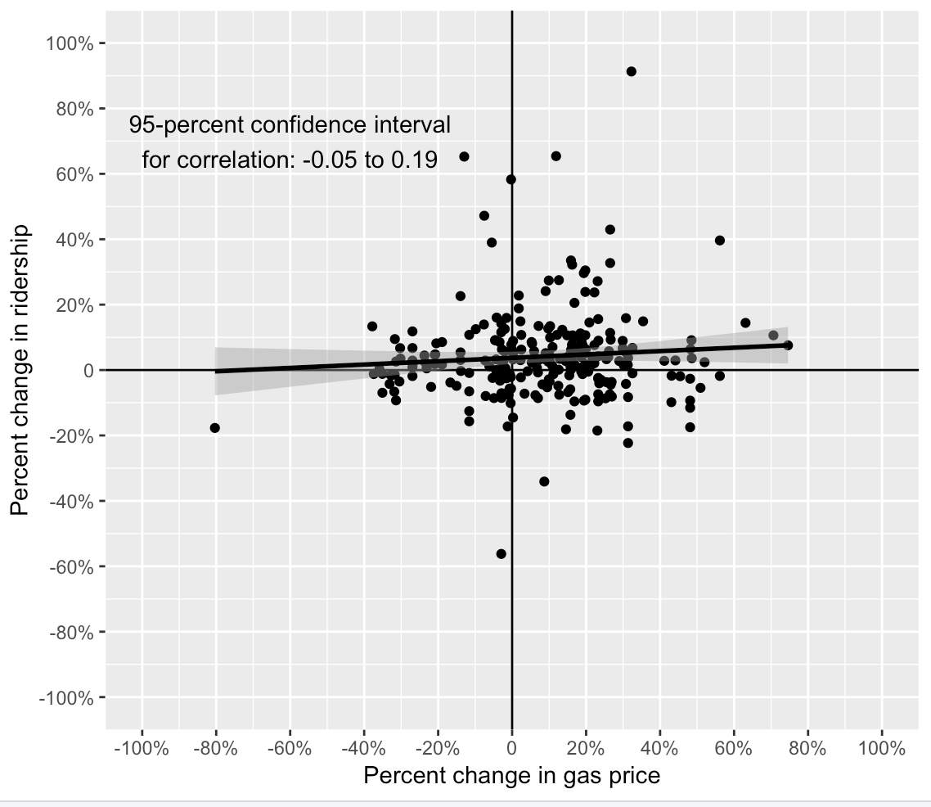

**Figure 21.** Correlation between percent change in ridership and gas price

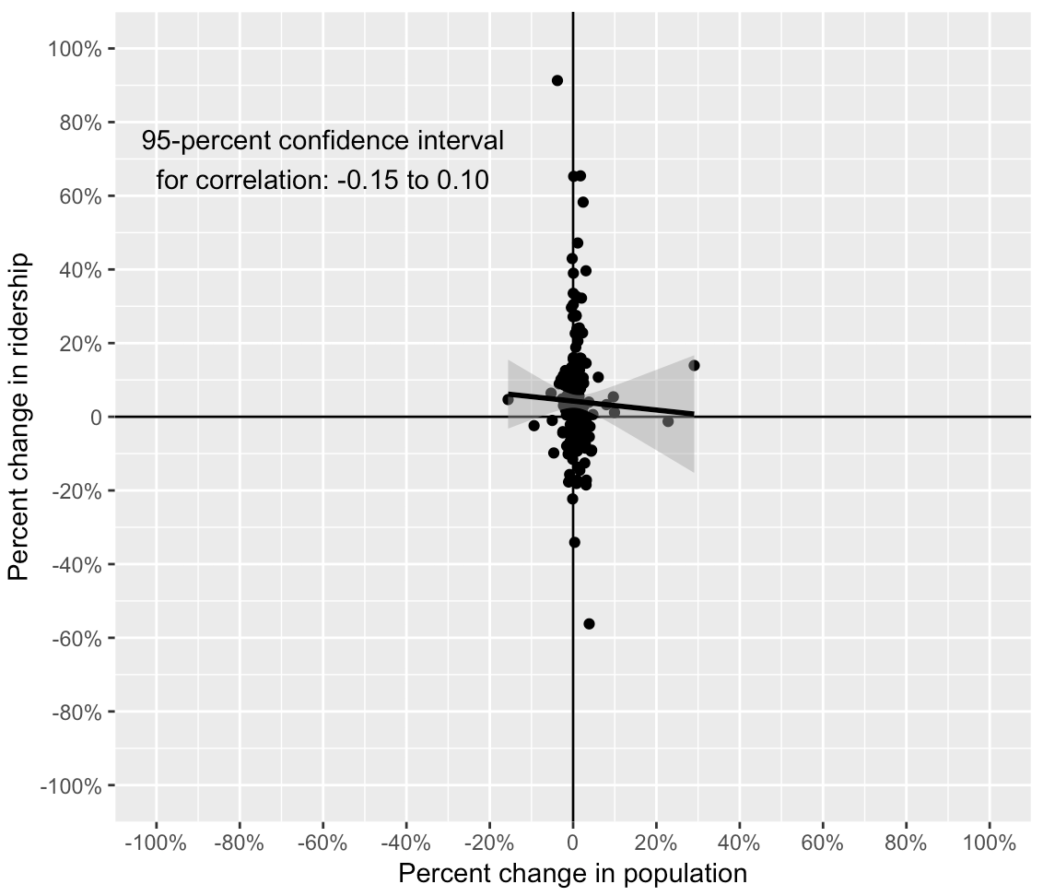

**Figure 22.** Correlation between percent change in ridership and population

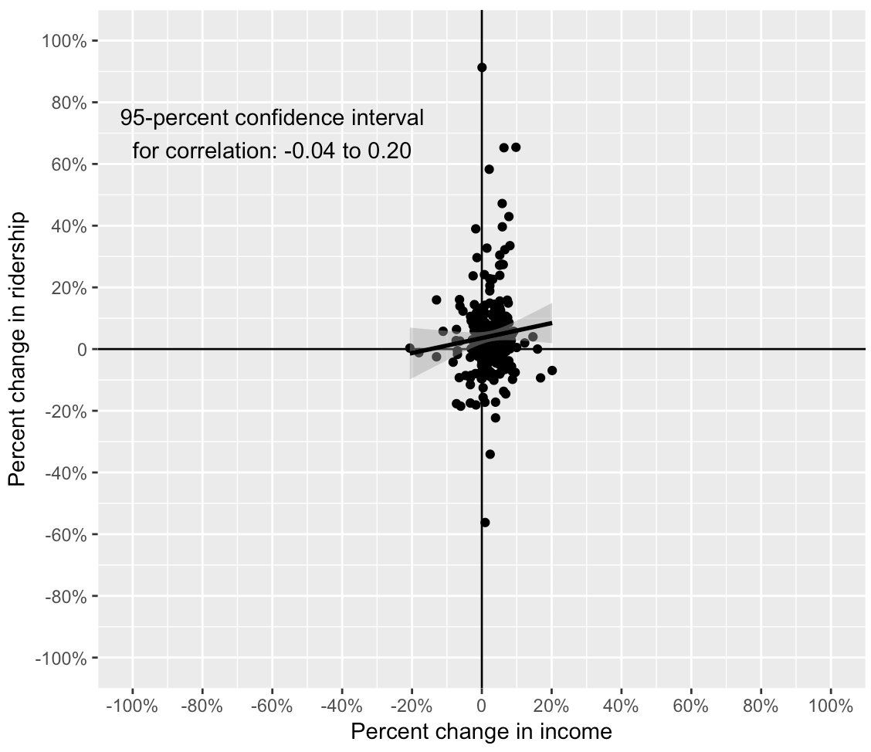

**Figure 23.** Correlation between percent change in ridership and percent change in income

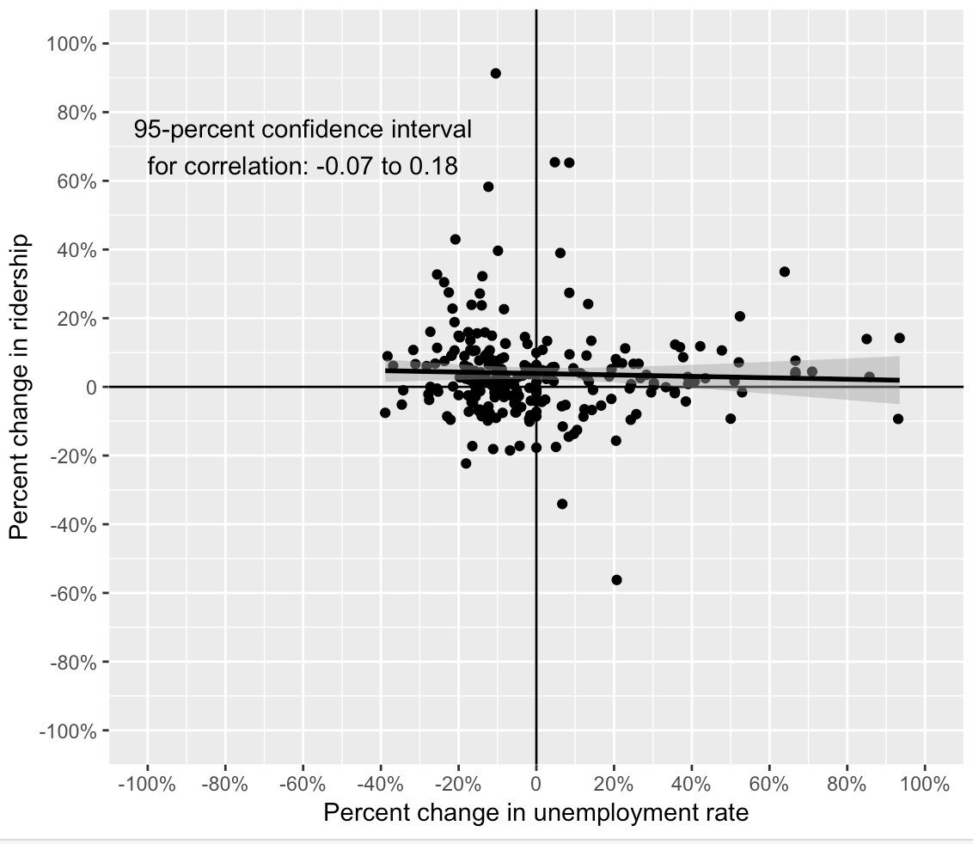

**Figure 24.** Correlation between percent change in ridership and unemployment rate

Figures 21 through 24 display the correlation between the percent change in ridership and the various control variables; unemployment rate, income, population and gas prices. Although many studies have identified a significant relationship between each of the control variables, included in the literature review, the correlations are not significant with a 95-percent confidence level for this sample, without controls for other factors. Table X further indicates how the correlations are not significant since the estimates are not all in the same direction for each of the three cases.

### Results of regression analysis with outliers excluded

The six projects deemed potential outliers are excluded in this regression analysis to determine if the results change when they are included. The six outliers are previously described in the methodology section of this thesis.

**Table 8.** Regression results with outliers excluded from sample

|  |  |  |  |  |  |  |  |  |  |
| --- | --- | --- | --- | --- | --- | --- | --- | --- | --- |
| Sample | Model Form 1:No indicator for new projects | | | Model Form 2: Dummy variable to indicate new projects | | | Model Form 3: Interaction variables to indicate new projects and year | | |
| R2 | 0.132 | | | 0.140 | | | 0.159 | | |
| n | 257 | | | 257 | | | 257 | | |
| Independent variable | Estimate | t-value | p-value | Estimate | t-value | p-value | Estimate | t-value | p-value |
| *Percent Change in control variables* | | | | | | | | | |
| Gas Price | 0.04 | 1.52 | 0.13 | 0.05 | 1.57 | 0.12 | 0.05 | 1.61 | 0.11 |
| Population | -0.05 | -0.18 | 0.86 | -0.09 | -0.35 | 0.73 | -0.04 | -0.14 | 0.89 |
| Unemployment | 0.03 | 0.85 | 0.39 | 0.04 | 1.02 | 0.31 | 0.04 | 0.93 | 0.35 |
| Income | 0.18 | 1.08 | 0.28 | 0.19 | 1.12 | 0.26 | 0.18 | 1.07 | 0.29 |
| *Ridership growth over prior year* | | | | | | | | | |
| 1st year after opening | **0.09** | **3.20** | **>0.001** | **0.08** | **3.03** | **0.002** | **0.06** | **2.46** | **0.01** |
| 2nd year after opening | 0.04 | 1.65 | 0.10 | 0.03 | 1.45 | 0.15 | 0.03 | 1.19 | 0.23 |
| 3rd year after opening | 0.01 | 0.56 | 0.58 | -0.0005 | 1.45 | 0.98 | 0.002 | 0.12 | 0.90 |
| 4th year after opening | **0.03** | **2.13** | **0.03** | 0.02 | 1.29 | 0.20 | 0.02 | 1.75 | 0.08 |
| 5th year after opening | 0.01 | 0.42 | 0.68 | -0.003 | -0.17 | 0.87 | 0.01 | 0.48 | 0.63 |
| *Dummy Variable* | | | | | | | | | |
| New line | - | - | - | 0.03 | 1.07 | 0.28 | - | - | - |
| *Interaction Variables* | | | | | | | | | |
| 1st year after opening: New line | - | - | - | - | - | - | 0.10 | 1.28 | 0.20 |
| 2nd year after opening: New line | - | - | - | - | - | - | 0.04 | 0.59 | 0.56 |
| 3rd year after opening: New line | - | - | - | - | - | - | 0.02 | 0.56 | 0.57 |
| 4th year after opening: New line | - | - | - | - | - | - | 0.005 | 0.17 | 0.87 |
| 5th year after opening: New line | - | - | - | - | - | - | -0.01 | -0.26 | 0.80 |
| *Note:* ***Bold*** *text represents 95-percent confidence level* | | | | | | | | | |

Table 8 displays the results from the regression analysis with the six outlier projects first year excluded. The model fit is slightly better for each model, model 1 (R2=0.132), model 2 (R2=0.14), and model 3 (R2=0.159), compared to the results excluding outliers. For both cases, model 3 is the best fit with an R2 value of 0.139 for the results including outliers. Another key distinction is that there is statistical significance after the fourth year of opening for model 1 when outliers are excluded, however when they are included it is not statistically significant. Since the fourth year is significant when the difference between new projects and expansion projects is not accounted for, this suggests that the ramp-up period may be longer for new projects, but the sample size of new projects is too small for this difference to show up as significant. Besides these key findings, each model still has significance in the first year after opening. The percent change estimate is also approximately the same for both cases. Figure 25, below, shows the percent increase in ridership controlling for external control variables based on the results from model 3.

**Figure 25.** Increase in ridership since prior year controlling for gas price, income, unemployment rate, and population for data without outliers

Figure 26, below, shows the estimate of the percent change in ridership for the first year after opening for the results with outliers included and results with outliers excluded. For each model (1, 2, and 3) the estimate is about the same. The results without outliers is about one percent higher for models 1 and 2, and approximately the same for model 3, which is the best fit model.

**Figure 26.** Percent change ridership first year after opening for results with outliers compared to results without outliers

Since the excluding outliers has a negligible effect on the results of the analysis and increases the model fit, I am confident that the results with the outliers include are representative of the sample. The 95-percent confidence intervals for both the sample with outliers and without outliers are about the same for each of the models. The difference between one percent change in ridership is not large enough to gather any further implications about the results and ridership ramp-up.

## Conclusions from results

The main conclusions to be drawn from the results is that there is a statistical significant increase in ridership in the first year after project opening, which can be identified as ridership ramp-up in each of the three models. None of the control variables, interaction variables, or binary variable has any significance in its coefficients. However, with the inclusion of the binary indicator variable and interaction variables, the model fit increases which indicates the inclusion of these variables has an effect on the results, but I cannot be sure what that affect is. The limitations of this analysis and further discussion of the results will follow in the conclusion chapter of this thesis.

# Conclusions and Discussion

The conclusions from this study describe the possible implications of ridership-ramp up and include future work that may be applicable to this study. An empirical study of NTD unlinked-passenger trip data was created to analyze transit ridership percent change over a five to six-year period after project opening. Both a controlled and descriptive analysis of these results are included in the study and evaluated for ridership ramp-up in fixed-guideway transit projects within the United States. The conclusions from this study are summarized below, including the limitations and assumptions made during the process, and future work and studies that could strengthen the results of this study.

## Discussion of Results

The results summarized above support the conclusion that ridership ramp-up does play a role in ridership increases during the initial years after project opening. Controlling for fluctuation in gas prices, population, income, and unemployment, ridership on rail transit projects increases by about one to eleven percent between the opening year and the first year after project opening. It is possible that it takes longer for the public to become aware of new projects than of expansion projects on new systems, which may lead to a longer ramp-up period for ridership gains.

### Limitations and Assumptions

The key limitations of this study include small sample size, limited control variables, and timeframe for the analysis. Most of the limitations are due to limitations in the databases. Control variables that could have impacts on the percent change in ridership are pre-opening marketing, the built-environment surrounding the system, car ownership, average fares and existing dependence on the transit system. Control variables like pre-opening marketing and existing dependence on transit have no quantitative source of measurement that could be collected in the time period I analyzed (1991-2015). While these external variables would have an effect on ridership, there is no current way that they can be analyzed quantitatively with the other control variables.

#### Sample size

The sample was limited to 55 projects in the United States. While this is an appropriate size to be analyzed, since it is small there may be a question of how accurate the results are and if the statistical significance is due to the smaller sample size. However, all projects that are available from the NTD and fit the criteria of the study are included in the analysis, therefore the sample is a census of all possible data.

#### Available Control Data

Collecting data to control the analysis involved various sources such as the United State Census, the Bureau of Labor Statistics, National Transit Database, and United States Energy Administration. Although most of this data is readily available, I had to interpolate some of the data since the census is conducted every ten years. Other data collected was difficult to find consistent sources for the 1992 to 2015 time range I was analyzing. Many control variables could not be included since there was insufficient data for the entire time-period or unreliable sources. Additionally, compiling the data from the various databases was a long process, so given more time availability or undergraduate research assistants, more data could be collected to analyze. This availability limited the amount of data analyzed and could change the results found from the analysis. The future work section discusses mitigations to these problems and potential solutions.

The analysis of data required a large scale of data collected from various sources; the National Transit Database, Bureau of Labor Statistics, United States Census, etc. While these sources were reliable for the most part, some data would be either missing or reported inconsistently. The ridership data (UPT) from the NTD was not updated past 2015 and had various years of missing data. While average transit fare would have allowed some of the outlier projects to be analyzed, the NTD does not include any fare data between 1991 and 2001. This would reduce the sample size by over half. For future studies where additional years of projects could be added, average transit fare would be a key control variable to include. Other variables that I would have liked to include is the built-environment/land-use, car ownership, and auto/highway characteristics. Many of these control variables are offered in the 2000 census, but not the 1990 census and there is no way to collect this information for each year between 1991 and 2001. This limited the amount of years after a project opening I could analyze and the sample size of projects available to use.

While including more control variables could increase the accuracy of this study, it would reduce the sample size due to the lack of available control variable data. Each project included in the sample has unique characteristics and outside variables that affect the ridership trends. Case studies of six projects included as potential outliers are included in the study and identify how unusual the project characteristics are.

#### Assumptions

The population data by city was found from the United States Census in 1990 and 2000, and later found on the US Census website which includes annual population data by city from 2005 after. I used linear interpolation to calculate the population by city from 1990 to 2000, and 2000 to 2005. Linear interpolation and logarithmic interpolation was found to yield similar results, so I decided to use linear interpolation for simplicity. While the span of 15 years of interpolation would not have significant effects on the population, it does ignore the annual nuances in populations in various cities that could reflect changes in ridership each year.

Additionally, the only control variables used in the analysis are; percent change in gas price, percent change in population, percent change in income, percent change in unemployment, and growth of a system. To increase the accuracy of the analysis I would include additional control variables that could have an impact on the results. These variables could include marketing of the transit agency, commuter mode share, car ownership, and more. These control variables have proven impacts on transit ridership proved in outside literature and therefore could influence my results.

## Conclusions from findings

In light of these findings, how should ridership ramp-up be accounted for in evaluating the performance of new rail transit projects?

One approach would be to wait to measure ridership for purposes of performance evaluation until the period of ramp-up has passed. The results of this analysis suggest that most ridership ramp-up has been realized by the end of the second year, so waiting until the second year after project opening to measure performance in terms of ridership may be appropriate. Indeed, this is precisely the approach taken by the FTA in their requirement that Before and After Studies of New Starts projects be conducted two years after project opening. A longer wait between project opening and project evaluation increases the chances that other events (such as economic shocks, changes in fare policy, or the construction of additional projects) will occur in the intervening years to increase the difficulty of attributing ridership gains to a specific project.

Another approach that may be appropriate for comparing opening-year ridership forecasts to observed opening year ridership would be to adjust opening-year forecasts down by one to eleven percent to account for unrealized ridership ramp-up. However, based on the limitations of this analysis and small sample size, further research is indicated to determine how to account for ramp-up in rail projects.

However, based on the best-fitting model most of the ramp-up has occurred by the end of the first year and is modest. Large errors in ridership forecasts, such as those documented by Flyvbjerg (Flyvbjerg 2005) and Pickrell (Pickrell 1992) cannot be explained by solely by ridership ramp-up. In recent years ridership forecast accuracy has improved. As knowledge increases on how to forecast ridership and improvements to forecasting methods are made, over time forecasts are becoming more accurate (Schmitt 2016). In the 1989 study by Pickrell (Pickrell 1992) he found that on average forecasts exceeded actual ridership by about 65 percent. In a study regarding forecast accuracy for New Starts projects, Voulgaris (Voulgaris 2018) found that the relationship between forecast error and the year the forecast was prepared shows a trend of improved forecast accuracy over time As forecast accuracy improves, the relative importance of ridership ramp-up is likely to increase as an explanation of any inaccuracies in forecasting. However, ramp-up is most likely within an acceptable margin of error for forecast accuracy at this point in time.

This study represents an initial step toward a better understanding of the role of ridership ramp-up in observed variation in ridership in the initial years of rail transit project operation. Future research is needed to determine what influence specific project characteristics or external factors have on the magnitude and timing of ridership ramp-up

## Future Work

Given that the data was limited to 5 to 6 years, fixed-guideway projects, and a small amount of control variables potential future research questions include:

* Do non-fixed guideway transit modes experience ridership ramp-up?
* What are additional control variables that may affect transit ridership ramp-up?
* What are the effects of ramp-up after the fifth year of the project opening? The tenth year? The fifteenth year?

With additional time ridership ramp-up will be able to be studied further and additional control variables addressed. As of now, the data collected and analyzed indicates that ridership ramp-up does exist for fixed-guideway transit projects after the first year of the project opening on average 6 percent.

# References

Allison C. Yoh, Brian D. Taylor, David A. King, and Hiroyuki Iseki. 2006. “Institutional Issues and Arrangements in Interoperable Transit Smart Card Systems: A Review of the Literature on California, United States, and International Systems.” *Institute of Transportation Studies University of California, Los Angeles School of Public Affairs*, March. https://merritt.cdlib.org/d/ark:%252F13030%252Fm5n331bb/1/producer%252F65182701.pdf.

Beth Drupal. 2015. “Sounder Celebrates 15 Years of Commuter Rail Service.” Text. Sound Transit. September 18, 2015. https://www.soundtransit.org/About-Sound-Transit/News-and-events/News-releases/sounder-celebrates-15-years-commuter-rail-service.

Carole Abel Lewis. 2012. “REVIEWING, ANALYZING AND UPDATING MARKETING STRATEGIES TO INCREASE PUBLIC TRANSIT RIDERSHIP.” Southwest Region University Transportation Center Center for Transportation Training and Research Texas Southern University 3100 Cleburne Houston, Texas 77004. https://static.tti.tamu.edu/swutc.tamu.edu/publications/technicalreports/476660-00050-1.pdf.

Chakraborty, Arnab, and Sabyasachee Mishra. n.d. “Land Use and Transit Ridership Connections: Implications for State-Level Planning Agencies.” *Land Use Policy*. https://ac.els-cdn.com/S0264837712000786/1-s2.0-S0264837712000786-main.pdf?_tid=f0e55e94-15f0-11e8-8f47-00000aacb35f&acdnat=1519098701_06546c218056c4bbfcbb8a61b5b91878.

Chang, Justin, Sung-bong Chung, Kyu-hwa Jung, and Ki-min Kim. 2010. “Patronage Ramp-Up Analysis Model Using a Heuristic F-Test.” *Transportation Research Record: Journal of the Transportation Research Board* 2175 (December): 84–91. https://doi.org/10.3141/2175-10.

Chen, Cynthia, Don Varley, and Jason Chen. 2011. “What Affects Transit Ridership? A Dynamic Analysis Involving Multiple Factors, Lags and Asymmetric Behaviour.” *Urban Studies* 48 (9): 1893–1908. https://doi.org/10.1177/0042098010379280.

Colin Cameron, A., and Douglas L. Miller. 2015. “A Practitioner’s Guide to Cluster-Robust Inference.” *Journal of Human Resources* 50 (2): 317–72. https://doi.org/10.3368/jhr.50.2.317.

Currie, Graham. 2007. “Bus Rapid Transit in Australasia: Performance, Lessons Learned and Futures.” Journal of Public Transportation, 9 (3): 1-22. http://scholarcommons.usf.edu/jpt/vol9/iss3/1/.

Damien Newton, and Joe Linton. 2015. “Do Gas Prices Impact Transit Ridership? Sure. But There’s More….” *Streetsblog California* (blog). October 28, 2015. https://cal.streetsblog.org/2015/10/28/do-gas-prices-impact-transit-ridership-sure-but-theres-more/.

Daniel Boyle. 2006. “Fixed-Route Transit Ridership Forecasting and Service Planning Methods.” *TCRP* Synthesis 66. file:///Users/jillshinn/Downloads/14001.pdf.

Daniel Duff, Edward J. Gill, Jr., and G. Kent Woodman. 2009. *Legal Handbook for the New Starts Process*. National Acacdemy of Sciences. http://nap.edu/22970.

Dehornoy, Julien. 2015. *Rail Economics, Policy and Regulation in Europe*. Edward Elgar Publishing.

Douglas. 2005. “Patronage Ramp-Up Factors for New Rail Services.” Douglas Economic, Ltd. http://atrf.info/papers/2005/2005_McGregor_Raimond.pdf.

“Ethics in Federally Funded Public Transportation.” 2016. Text. FTA. January 5, 2016. https://www.transit.dot.gov/fta-web-policies/ethics/ethics-federally-funded-public-transportation.

Ewing, Reid, and Robert Cervero. 2001. “Travel and the Built Environment: A Synthesis.” *Transportation Research Record: Journal of the Transportation Research Board* 1780 (January): 87–114. https://doi.org/10.3141/1780-10.

“Federal Register, Volume 65 Issue 236 (Thursday, December 7, 2000).” n.d. Accessed November 5, 2018. https://www.gpo.gov/fdsys/pkg/FR-2000-12-07/html/00-30921.htm.

“Fixing America’s Surface Transportation Act or the FAST Act - FHWA | Federal Highway Administration.” n.d. Accessed June 5, 2018. https://www.fhwa.dot.gov/fastact/.

Flyvbjerg, Bent. 2005. “Measuring Inaccuracy in Travel Demand Forecasting: Methodological Considerations Regarding Ramp up and Sampling.” Department of Development and Planning, Aalborg University Fibigerstraede. https://arxiv.org/pdf/1303.7401.pdf.

Flyvbjerg, Bent, Mette K. Skamris Holm, and Søren L. Buhl. 2005. “How (In)Accurate Are Demand Forecasts in Public Works Projects?: The Case of Transportation.” *Journal of the American Planning Association* 71 (2): 131–46. https://doi.org/10.1080/01944360508976688.

Flyvbjerg, Bent, Mette K. Skamris Holm, and Søren L. Buhl. 2005. “How (In)Accurate Are Demand Forecasts in Public Works Projects?: The Case of Transportation.” *Journal of the American Planning Association* 71 (2): 131–46. https://doi.org/10.1080/01944360508976688.

Graham, Nathaniel, Mahmood Arai, and Björn Hagströmer. 2016. *Multiwaycov: Multi-Way Standard Error Clustering*. R Package Version 1.2.3. https://CRAN.R-project.org/package=multiwayvcov.

“History of ACE - ACE | Altamont Corridor Express.” n.d. Accessed October 28, 2018. http://www.acerail.com/About/History-of-ACE.

John Neff, and Larry Pham. 2007. “A Profile of Public Transportation Passenger Demographics and Travel Characteristics Reported in On-Board Surveys.” American Public Transportation Association. https://www.apta.com/resources/statistics/Documents/transit_passenger_characteristics_text_5_29_2007.pdf.

July 5, Matt Van Hattem |, and 2006. n.d. “Massachusetts Bay Transportation Authority (MBTA) | Trains Magazine.” TrainsMag.Com. Accessed October 28, 2018. http://trn.trains.com/railroads/2006/07/massachusetts-bay-transportation-authority-mbta.

Kriger, D, and S. Shiu. 2006. “NCHRP Synthesis of Highway Practice 364: Estimating Toll Road Demand and Revenue.” . Transportation Research Board of the National Academies, Washington, D.C.,. https://transportation.ky.gov/Planning/Documents/Estimating%20Toll%20Road%20Demand%20and%20Revenue.pdf.

Lane, Bradley W. n.d. “The Relationship between Recent Gasoline Price Fluctuations and Transit Ridership in Major US Cities.” *Journal of Transport Geography* 18. https://ac.els-cdn.com/S0966692309000520/1-s2.0-S0966692309000520-main.pdf?_tid=3273a5b0-15f0-11e8-848d-00000aab0f26&acdnat=1519098382_1e54553ca1c114239f1286a935bfe2d4.

Lewis-Workman. 2007. “The Predicted and Actual Impacts of New Starts Projects-2007. Capital Cost and Ridership.” Federal Transit Administration Office of Planning and Environment. https://www.transit.dot.gov/funding/grant-programs/capital-investments/and-after-studies-new-starts-projects.

“Link Light Rail | Getting Around Downtown Tacoma for Free.” 2018. Travel Tacoma. 2018. http://www.traveltacoma.com/plan/link-light-rail/.

“MAP-21 | Federal Highway Administration.” n.d. Accessed June 5, 2018. https://www.fhwa.dot.gov/map21/.

“METRO Blue Line Facts - Metropolitan Council.” n.d. Accessed October 28, 2018. https://metrocouncil.org/About-Us/Facts/TransportationF/FACTS-METRO-Blue-Line.aspx.

Pelletier, Marie-Pier, Martin Trépanier, and Catherine Morency. 2011. “Smart Card Data Use in Public Transit: A Literature Review.” *Transportation Research Part C: Emerging Technologies* 19 (4): 557–68. https://doi.org/10.1016/j.trc.2010.12.003.

Pickrell, Don. 1992. “A Desire Named Streetcar Fantasy and Fact in Rail Transit Planning.” *American Planning Association. Journal of the American Planning Association*. http://www.csus.edu/indiv/c/chalmersk/econ251fa12/adesirenamedstreetcar.pdf.

“Proposed New Starts and Small Starts Policy Guidance.” 2013. *US Department of Transportation Federal Transit Administration*, January.

Schmitt D. 2016. “A Transit Forecasting Accuracy Database: Beginning to Enjoy the ‘Outside View.’” *Presented at the Transportation Research Board 95th Annual Meeting Transportation Research Board, Washington DC*.

Schmitt, David. 2016. “TRANSIT FORECASTING UNCERTAINTY & ACCURACY,” November, 33.

Spielberg. 2007. “Contractor Performance Assessment Report.” Federal Transit Administration Office of Planning and Environment U.S. Department of Transportation.

Taylor, Brian D., and Camille N.Y. Fink. n.d. “The Factors Influencing Transit Ridership: A Review and Analysis of the Ridership Literature.” *UCLA Institute of Transportation Studies*. http://www.reconnectingamerica.org/assets/Uploads/ridersipfactors.pdf.

Taylor, Brian D., Douglas Miller, Hiroyuki Iseki, and Camille Fink. n.d. “Nature and/or Nurture? Analyzing the Determinants of Transit Ridership across US Urbanized Areas.” *Transportation Research Part A*. https://ac.els-cdn.com/S0965856408001274/1-s2.0-S0965856408001274-main.pdf?_tid=b78ff2f6-15f7-11e8-9e4b-00000aab0f26&acdnat=1519101612_2da83976dd2f5085910452f073c43184.

“United States - SEDS - U.S. Energy Information Administration (EIA).” 2018. October 7, 2018. https://www.eia.gov/state/seds/seds-data-complete.php?sid=US.

Voulgaris, Carole Turley. 2017. “In Forecasts We Trust? Correlates with Ridership Accuracy for Fixed-Guideway Transit Projects.” Department of Civil and Environmental Engineering. http://amonline.trb.org/18-03343-1.3991182?qr=1.

———. 2018. “In Forecasts We Trust? Correlates with Ridership Forecast Accuracy for Fixed-Guideway Transit Projects.” In *97th Annual Meeting of the Transportation Research Board*. Transportation Research Board. https://trid.trb.org/view/1495735.

Zimmerman, Samuel. n.d. “UMTA and Major Investments: Evaluation Process and Results.” *Transportation Research Record: Journal of the Transportation Research Board*.

# Appendix A – R Code Inputs

library("miceadds")

library("multiwayvcov")

library("stats")

library("ggplot2")

setwd("/Users/jillshinn/Desktop/Thesis/Data /FinalDatabase")

proj_data <- read.csv("Final_Database_9.29.csv", colClasses=c("character",

rep("numeric",6),

rep("integer",6)))

## remove projects that represent less than 5% of the system

proj_data <- proj_data[proj_data$pct_grow > 0.05,]

## remove blank rows

proj_data <- proj_data[!is.na(proj_data$project),]

## remove ridership increases with more than 100% growth

## this is six in the first year

proj_data <- proj_data[proj_data$ride_pcty<1,]

mean(proj_data$ride_pcty[proj_data$Y_1==1])

mean(proj_data$ride_pcty[proj_data$Y_2==1])

mean(proj_data$ride_pcty[proj_data$Y_3==1])

mean(proj_data$ride_pcty[proj_data$Y_4==1])

mean(proj_data$ride_pcty[proj_data$Y_5==1])

table(proj_data$ride_pcty[proj_data$Y_1==1]>0)/

length(proj_data$ride_pcty[proj_data$Y_1==1])

table(proj_data$ride_pcty[proj_data$Y_2==1]>0)/

length(proj_data$ride_pcty[proj_data$Y_2==1])

table(proj_data$ride_pcty[proj_data$Y_3==1]>0)/

length(proj_data$ride_pcty[proj_data$Y_3==1])

table(proj_data$ride_pcty[proj_data$Y_4==1]>0)/

length(proj_data$ride_pcty[proj_data$Y_4==1])

table(proj_data$ride_pcty[proj_data$Y_5==1]>0)/

length(proj_data$ride_pcty[proj_data$Y_5==1])

n <- table(proj_data$Y_1==1)["TRUE"]

hist(proj_data$ride_pcty[proj_data$Y_1==1 &

proj_data$ride_pcty<1],

breaks=seq(-1,1,by=0.05),

main=NULL,

xlab="Percent ridership growth in first year after project opening",

xlim=c(-1,1),ylim=c(0,15),xaxt="n")

axis(1, at = x<-seq(-1,1,by=0.25), labels = paste(x*100, "%", sep = "" ))

text(-0.6,6, labels=paste("n = ",n,sep=""))

n <- table(proj_data$Y_2==1)["TRUE"]

hist(proj_data$ride_pcty[proj_data$Y_2==1],

breaks=seq(-1,1,by=0.05),

main=NULL,

xlab="Percent ridership growth in second year after project opening",

xlim=c(-1,1),ylim=c(0,15),xaxt="n")

axis(1, at = x<-seq(-1,1,by=0.25), labels = paste(x*100, "%", sep = "" ))

text(-0.6,6, labels=paste("n = ",n,sep=""))

n <- table(proj_data$Y_3==1)["TRUE"]

hist(proj_data$ride_pcty[proj_data$Y_3==1],

breaks=seq(-1,1,by=0.05),

main=NULL,

xlab="Percent ridership growth in third year after project opening",

xlim=c(-1,1),ylim=c(0,15),xaxt="n")

axis(1, at = x<-seq(-1,1,by=0.25), labels = paste(x*100, "%", sep = "" ))

text(-0.6,6, labels=paste("n = ",n,sep=""))

n <- table(proj_data$Y_4==1)["TRUE"]

hist(proj_data$ride_pcty[proj_data$Y_4==1],

breaks=seq(-1,1,by=0.05),

main=NULL,

xlab="Percent ridership growth in fourth year after project opening",

xlim=c(-1,1),ylim=c(0,15),xaxt="n")

axis(1, at = x<-seq(-1,1,by=0.25), labels = paste(x*100, "%", sep = "" ))

text(-0.6,6, labels=paste("n = ",n,sep=""))

n <- table(proj_data$Y_5==1)["TRUE"]

hist(proj_data$ride_pcty[proj_data$Y_5==1],

breaks=seq(-1,1,by=0.05),

main=NULL,

xlab="Percent ridership growth in fifth year after project opening",

xlim=c(-1,1),ylim=c(0,15),xaxt="n")

axis(1, at = x<-seq(-1,1,by=0.25), labels = paste(x*100, "%", sep = "" ))

text(-0.6,6, labels=paste("n = ",n,sep=""))

cor<-cor.test(proj_data$gas_pcty,proj_data$ride_pcty)

lb <- format(cor$conf.int[1],nsmall=2,digits=1)

ub <- format(cor$conf.int[2],nsmall=2,digits=1)

ggplot(proj_data,aes(gas_pcty,ride_pcty)) +

geom_point() +

labs(x = "Percent change in gas price",

y = "Percent change in ridership") +

scale_x_continuous(limits=c(-1, 1),breaks=seq(-1, 1,by=0.2),

labels=c("-100%","-80%","-60%","-40%","-20%",

"0","20%","40%","60%","80%","100%")) +

scale_y_continuous(limits=c(-1, 1),breaks=seq(-1, 1,by=0.2),

labels=c("-100%","-80%","-60%","-40%","-20%",

"0","20%","40%","60%","80%","100%")) +

geom_hline(yintercept=0) +

geom_vline(xintercept=0) +

stat_smooth(method=lm,color="black") +

annotate("text",

x = -0.6, y = 0.7,

label = paste(

"95-percent confidence interval\nfor correlation: ",

lb," to ",ub,sep=""))

cor<-cor.test(proj_data$pop_pcty,proj_data$ride_pcty)

lb <- format(cor$conf.int[1],nsmall=2,digits=1)

ub <- format(cor$conf.int[2],nsmall=2,digits=1)

ggplot(proj_data,aes(pop_pcty,ride_pcty)) +

geom_point() +

labs(x = "Percent change in population",

y = "Percent change in ridership") +

scale_x_continuous(limits=c(-1, 1),breaks=seq(-1, 1,by=0.2),

labels=c("-100%","-80%","-60%","-40%","-20%",

"0","20%","40%","60%","80%","100%")) +

scale_y_continuous(limits=c(-1, 1),breaks=seq(-1, 1,by=0.2),

labels=c("-100%","-80%","-60%","-40%","-20%",

"0","20%","40%","60%","80%","100%")) +

geom_hline(yintercept=0) +

geom_vline(xintercept=0) +

stat_smooth(method=lm,color="black") +

annotate("text",

x = -0.6, y = 0.7,

label = paste(

"95-percent confidence interval\nfor correlation: ",

lb," to ",ub,sep=""))

cor<-cor.test(proj_data$inc_pcty,proj_data$ride_pcty)

lb <- format(cor$conf.int[1],nsmall=2,digits=1)

ub <- format(cor$conf.int[2],nsmall=2,digits=1)

ggplot(proj_data,aes(inc_pcty,ride_pcty)) +

geom_point() +

labs(x = "Percent change in income",

y = "Percent change in ridership") +

scale_x_continuous(limits=c(-1, 1),breaks=seq(-1, 1,by=0.2),

labels=c("-100%","-80%","-60%","-40%","-20%",

"0","20%","40%","60%","80%","100%")) +

scale_y_continuous(limits=c(-1, 1),breaks=seq(-1, 1,by=0.2),

labels=c("-100%","-80%","-60%","-40%","-20%",

"0","20%","40%","60%","80%","100%")) +

geom_hline(yintercept=0) +

geom_vline(xintercept=0) +

stat_smooth(method=lm,color="black") +

annotate("text",

x = -0.6, y = 0.7,

label = paste(

"95-percent confidence interval\nfor correlation: ",

lb," to ",ub,sep=""))

cor<-cor.test(proj_data$unem_pcty,proj_data$ride_pcty)

lb <- format(cor$conf.int[1],nsmall=2,digits=1)

ub <- format(cor$conf.int[2],nsmall=2,digits=1)

ggplot(proj_data,aes(unem_pcty,ride_pcty)) +

geom_point() +

labs(x = "Percent change in unemployment rate",

y = "Percent change in ridership") +

scale_x_continuous(limits=c(-1, 1),breaks=seq(-1, 1,by=0.2),

labels=c("-100%","-80%","-60%","-40%","-20%",

"0","20%","40%","60%","80%","100%")) +

scale_y_continuous(limits=c(-1, 1),breaks=seq(-1, 1,by=0.2),

labels=c("-100%","-80%","-60%","-40%","-20%",

"0","20%","40%","60%","80%","100%")) +

geom_hline(yintercept=0) +

geom_vline(xintercept=0) +

stat_smooth(method=lm,color="black") +

annotate("text",

x = -0.6, y = 0.7,

label = paste(

"95-percent confidence interval\nfor correlation: ",

lb," to ",ub,sep=""))

## all projects

model.1 <- lm.cluster(proj_data,

ride_pcty~gas_pcty+pop_pcty+unem_pcty+inc_pcty+

Y_1+Y_2+Y_3+Y_4+Y_5+0,

proj_data$project)

summary(model.1)

## with a dummy variable

model.5 <- lm.cluster(proj_data,

ride_pcty~gas_pcty+pop_pcty+unem_pcty+inc_pcty+

Y_1+Y_2+Y_3+Y_4+Y_5+new+0,

proj_data$project)

summary(model.5)

## with interaction variables

proj_data$nY_1 <- proj_data$new*proj_data$Y_1

proj_data$nY_2 <- proj_data$new*proj_data$Y_2

proj_data$nY_3 <- proj_data$new*proj_data$Y_3

proj_data$nY_4 <- proj_data$new*proj_data$Y_4

proj_data$nY_5 <- proj_data$new*proj_data$Y_5

model.6 <- lm.cluster(proj_data,

ride_pcty~gas_pcty+pop_pcty+unem_pcty+inc_pcty+

Y_1+Y_2+Y_3+Y_4+Y_5+

nY_1+nY_2+nY_3+nY_4+nY_5+0,

proj_data$project)

summary(model.6)

# Appendix B- Database

|  |  |  |  |  |  |  |  |  |  |  |  |
| --- | --- | --- | --- | --- | --- | --- | --- | --- | --- | --- | --- |
| project | ride_pcty | gas_pcty | pop_pcty | unem_pcty | inc_pcty | pct_grow | Y_1 | Y_2 | Y_3 | Y_4 | Y_5 |
| One | 0.06064 | 0.00000 | 0.00104 | -0.28235 | 0.06769 | 0.133000454 | 1 | 0 | 0 | 0 | 0 |
| One | -0.05654 | -0.00683 | 0.00179 | 0.06557 | 0.08523 | 0.133000454 | 0 | 1 | 0 | 0 | 0 |
| One | 0.04857 | 0.19395 | 0.00443 | 0.01538 | 0.03895 | 0.133000454 | 0 | 0 | 1 | 0 | 0 |
| One | 0.06315 | -0.02765 | -0.00210 | -0.03030 | 0.04371 | 0.133000454 | 0 | 0 | 0 | 1 | 0 |
| One | 0.01697 | -0.18957 | -0.00189 | -0.14063 | 0.04590 | 0.133000454 | 0 | 0 | 0 | 0 | 1 |
| Two | -0.02410 | -0.05289 | 0.00643 | -0.20000 | 0.03692 | 0.3893 | 1 | 0 | 0 | 0 | 0 |
| Two | -0.01213 | -0.00649 | 0.00543 | -0.05000 | 0.04749 | 0.3893 | 0 | 1 | 0 | 0 | 0 |
| Two | 0.10614 | 0.16340 | 0.00742 | -0.21053 | 0.04872 | 0.3893 | 0 | 0 | 1 | 0 | 0 |
| Two | 0.14900 | 0.02247 | 0.01218 | -0.20000 | 0.02272 | 0.3893 | 0 | 0 | 0 | 1 | 0 |
| Two | 0.22618 | -0.13956 | 0.00504 | -0.08333 | 0.03124 | 0.3893 | 0 | 0 | 0 | 0 | 1 |
| Three | -0.10113 | -0.00409 | -0.01193 | -0.01754 | 0.03455 | 0.066115702 | 1 | 0 | 0 | 0 | 0 |
| Three | 0.00665 | 0.06712 | -0.01415 | -0.10714 | 0.07665 | 0.066115702 | 0 | 1 | 0 | 0 | 0 |
| Three | -0.07698 | 0.06290 | -0.01257 | -0.12000 | 0.01086 | 0.066115702 | 0 | 0 | 1 | 0 | 0 |
| Three | 0.00543 | -0.01812 | -0.01207 | -0.09091 | 0.07502 | 0.066115702 | 0 | 0 | 0 | 1 | 0 |
| Three | 0.02302 | -0.23493 | -0.01130 | -0.10000 | 0.00642 | 0.066115702 | 0 | 0 | 0 | 0 | 1 |
| Four | 3.06347 | -0.01736 | -0.00083 | -0.19643 | 0.04074 | 0.069767442 | 1 | 0 | 0 | 0 | 0 |
| Four | -0.34090 | 0.08696 | 0.00382 | 0.06667 | 0.02385 | 0.069767442 | 0 | 1 | 0 | 0 | 0 |
| Four | -0.03476 | 0.10125 | 0.00410 | 0.00000 | 0.02547 | 0.069767442 | 0 | 0 | 1 | 0 | 0 |
| Four | -0.02946 | -0.03405 | 0.01724 | -0.08333 | 0.03760 | 0.069767442 | 0 | 0 | 0 | 1 | 0 |
| Four | 0.04681 | -0.20917 | -0.15611 | -0.15909 | 0.00766 | 0.069767442 | 0 | 0 | 0 | 0 | 1 |
| Five | 0.08098 | 0.05402 | 0.00240 | 0.20455 | 0.06069 | 1.00000 | 1 | 0 | 0 | 0 | 0 |
| Five | 0.10768 | 0.12157 | 0.00287 | -0.16981 | 0.03115 | 1.00000 | 0 | 1 | 0 | 0 | 0 |
| Five | 0.00008 | -0.04357 | 0.00302 | -0.27273 | 0.15948 | 1.00000 | 0 | 0 | 1 | 0 | 0 |
| Five | 0.04798 | -0.20778 | 0.00650 | 0.03125 | 0.04790 | 1.00000 | 0 | 0 | 0 | 1 | 0 |
| Five | -0.08649 | 0.25245 | 0.00032 | 0.12121 | 0.02044 | 1.00000 | 0 | 0 | 0 | 0 | 1 |
| Six | 3.20324 | -0.00122 | 0.00231 | 0.09524 | 0.07594 | 1.00000 | 1 | 0 | 0 | 0 | 0 |
| Six | 0.01338 | 0.10840 | 0.00678 | -0.06522 | 0.00599 | 1.00000 | 0 | 1 | 0 | 0 | 0 |
| Six | 0.07775 | -0.00220 | 0.00710 | -0.11628 | 0.05575 | 1.00000 | 0 | 0 | 1 | 0 | 0 |
| Six | 0.08555 | -0.18943 | -0.00185 | -0.13158 | 0.07786 | 1.00000 | 0 | 0 | 0 | 1 | 0 |
| Six | -0.01262 | 0.11141 | 0.22810 | -0.09091 | 0.03386 | 1.00000 | 0 | 0 | 0 | 0 | 1 |
| Seven | 0.02321 | 0.05306 | 0.00279 | 0.02564 | 0.03934 | 0.075428571 | 1 | 0 | 0 | 0 | 0 |
| Seven | 0.03369 | 0.08786 | -0.00415 | -0.10000 | 0.04154 | 0.075428571 | 0 | 1 | 0 | 0 | 0 |
| Seven | -0.07553 | -0.00950 | 0.00656 | -0.38889 | 0.09553 | 0.075428571 | 0 | 0 | 1 | 0 | 0 |
| Seven | 0.08170 | -0.20504 | 0.01135 | -0.09091 | 0.00924 | 0.075428571 | 0 | 0 | 0 | 1 | 0 |
| Eight | 0.03058 | 0.14225 | -0.02315 | 0.18750 | 0.01634 | 1.00000 | 1 | 0 | 0 | 0 | 0 |
| Eight | 0.12554 | -0.01993 | -0.01857 | -0.07895 | 0.04962 | 1.00000 | 0 | 1 | 0 | 0 | 0 |
| Eight | 0.00514 | -0.23126 | -0.01606 | -0.05714 | 0.09980 | 1.00000 | 0 | 0 | 1 | 0 | 0 |
| Eight | 0.02887 | 0.16198 | -0.01471 | -0.18182 | 0.02831 | 1.00000 | 0 | 0 | 0 | 1 | 0 |
| Eight | -0.05440 | 0.50925 | 0.03896 | 0.16667 | 0.00106 | 1.00000 | 0 | 0 | 0 | 0 | 1 |
| Nine | 0.09935 | 0.10263 | -0.02249 | 0.00000 | 0.07193 | 0.095238095 | 1 | 0 | 0 | 0 | 0 |
| Nine | 0.08569 | -0.03405 | -0.02117 | -0.08333 | 0.06119 | 0.095238095 | 0 | 1 | 0 | 0 | 0 |
| Nine | 0.01856 | -0.20917 | -0.01816 | -0.15909 | 0.07135 | 0.095238095 | 0 | 0 | 1 | 0 | 0 |
| Nine | 0.03002 | 0.10104 | -0.02011 | -0.16216 | 0.04377 | 0.095238095 | 0 | 0 | 0 | 1 | 0 |
| Nine | 0.02948 | 0.44130 | 0.02539 | 0.12903 | 0.02538 | 0.095238095 | 0 | 0 | 0 | 0 | 1 |
| Ten | 0.18857 | 0.01790 | 0.00638 | -0.21053 | 0.02272 | 0.47573 | 1 | 0 | 0 | 0 | 0 |
| Ten | 0.05405 | -0.13956 | 0.00940 | 0.00000 | 0.03124 | 0.47573 | 0 | 1 | 0 | 0 | 0 |
| Ten | 0.07903 | 0.16220 | 0.00989 | -0.11667 | 0.06584 | 0.47573 | 0 | 0 | 1 | 0 | 0 |
| Ten | 0.15863 | 0.30769 | 0.01899 | -0.13208 | 0.07305 | 0.47573 | 0 | 0 | 0 | 1 | 0 |
| Ten | 0.02514 | -0.02941 | 0.00994 | 0.43478 | 0.00953 | 0.47573 | 0 | 0 | 0 | 0 | 1 |
| Eleven | 0.22799 | 0.01790 | 0.02277 | -0.21569 | 0.02272 | 1.00000 | 1 | 0 | 0 | 0 | 0 |
| Eleven | 0.03082 | -0.13956 | 0.01994 | -0.10000 | 0.03124 | 1.00000 | 0 | 1 | 0 | 0 | 0 |
| Eleven | 0.32218 | 0.16220 | 0.02012 | -0.13889 | 0.06584 | 1.00000 | 0 | 0 | 1 | 0 | 0 |
| Eleven | -0.04231 | 0.30769 | 0.02869 | 0.00000 | 0.07305 | 1.00000 | 0 | 0 | 0 | 1 | 0 |
| Twelve | -0.02115 | -0.00343 | -0.00675 | -0.27778 | 0.04430 | 0.351778656 | 1 | 0 | 0 | 0 | 0 |
| Twelve | -0.05156 | -0.21904 | -0.00440 | -0.34615 | 0.05736 | 0.351778656 | 0 | 1 | 0 | 0 | 0 |
| Twelve | -0.05875 | 0.15712 | -0.00393 | -0.03922 | 0.07878 | 0.351778656 | 0 | 0 | 1 | 0 | 0 |
| Twelve | 0.06415 | 0.48223 | -0.05289 | -0.12245 | 0.00839 | 0.351778656 | 0 | 0 | 0 | 1 | 0 |
| Twelve | 0.01154 | -0.06164 | 0.02294 | 0.30233 | 0.05443 | 0.351778656 | 0 | 0 | 0 | 0 | 1 |
| Thirteen | -0.01662 | -0.01716 | 0.00035 | -0.10769 | 0.06058 | 0.133116883 | 1 | 0 | 0 | 0 | 0 |
| Thirteen | -0.03800 | -0.16708 | 0.00113 | -0.27586 | 0.07724 | 0.133116883 | 0 | 1 | 0 | 0 | 0 |
| Thirteen | -0.06735 | 0.15120 | 0.00098 | 0.14286 | 0.01449 | 0.133116883 | 0 | 0 | 1 | 0 | 0 |
| Thirteen | -0.09819 | 0.43043 | -0.04636 | -0.12500 | 0.08795 | 0.133116883 | 0 | 0 | 0 | 1 | 0 |
| Thirteen | 0.02921 | -0.07273 | -0.01263 | 0.85714 | -0.02740 | 0.133116883 | 0 | 0 | 0 | 0 | 1 |
| Fourteen | -0.00289 | -0.13861 | -0.00126 | -0.01786 | 0.03124 | 0.20252 | 1 | 0 | 0 | 0 | 0 |
| Fourteen | 0.07529 | 0.16220 | -0.00151 | -0.23636 | 0.06584 | 0.20252 | 0 | 1 | 0 | 0 | 0 |
| Fourteen | 0.05417 | 0.30769 | 0.09662 | 0.09524 | 0.07305 | 0.20252 | 0 | 0 | 1 | 0 | 0 |
| Fourteen | 0.14229 | -0.02941 | 0.00784 | 0.93478 | 0.00953 | 0.20252 | 0 | 0 | 0 | 1 | 0 |
| Fourteen | -0.06518 | -0.11602 | -0.00647 | 0.12360 | 0.00370 | 0.20252 | 0 | 0 | 0 | 0 | 1 |
| Fifteen | 0.10422 | 0.16176 | -0.02011 | -0.16216 | 0.04377 | 0.243055556 | 1 | 0 | 0 | 0 | 0 |
| Fifteen | 0.09125 | 0.48481 | 0.02539 | 0.12903 | 0.04463 | 0.243055556 | 0 | 1 | 0 | 0 | 0 |
| Fifteen | -0.07935 | -0.07161 | -0.01549 | 0.25714 | -0.01843 | 0.243055556 | 0 | 0 | 1 | 0 | 0 |
| Fifteen | 0.12511 | -0.09826 | -0.01305 | -0.02273 | 0.05375 | 0.243055556 | 0 | 0 | 0 | 1 | 0 |
| Fifteen | -0.17699 | -0.80346 | -0.01079 | 0.00000 | -0.07256 | 0.243055556 | 0 | 0 | 0 | 0 | 1 |
| Sixteen | 0.03429 | 0.12903 | 0.01157 | 0.03226 | 0.02786 | 0.160177976 | 1 | 0 | 0 | 0 | 0 |
| Sixteen | 0.03620 | 0.48571 | 0.01697 | -0.03125 | 0.00066 | 0.160177976 | 0 | 1 | 0 | 0 | 0 |
| Sixteen | 0.04440 | -0.23718 | 0.01392 | 0.70968 | -0.01189 | 0.160177976 | 0 | 0 | 1 | 0 | 0 |
| Sixteen | -0.04813 | 0.12485 | 0.02078 | -0.05660 | 0.01654 | 0.160177976 | 0 | 0 | 0 | 1 | 0 |
| Sixteen | -0.00459 | 0.18677 | 0.01852 | 0.24000 | 0.03357 | 0.160177976 | 0 | 0 | 0 | 0 | 1 |
| Seventeen | -0.07556 | 0.12727 | 0.00461 | -0.08696 | 0.02641 | 0.072289157 | 1 | 0 | 0 | 0 | 0 |
| Seventeen | 0.02826 | 0.41129 | 0.02422 | -0.04762 | 0.08442 | 0.072289157 | 0 | 1 | 0 | 0 | 0 |
| Seventeen | 0.13931 | -0.07619 | 0.29072 | 0.85000 | -0.06267 | 0.072289157 | 0 | 0 | 1 | 0 | 0 |
| Seventeen | -0.00519 | -0.04124 | 0.00333 | -0.08108 | 0.04401 | 0.072289157 | 0 | 0 | 0 | 1 | 0 |
| Seventeen | 0.07699 | 0.19032 | 0.00890 | -0.14706 | 0.02493 | 0.072289157 | 0 | 0 | 0 | 0 | 1 |
| Eighteen | 6.96550 | 0.30197 | -0.00510 | -0.13861 | 0.07305 | 1 | 1 | 0 | 0 | 0 | 0 |
| Eighteen | -0.56217 | -0.02941 | 0.03864 | 0.20690 | 0.00953 | 1 | 0 | 1 | 0 | 0 | 0 |
| Eighteen | -0.12543 | -0.11602 | 0.02806 | 0.10476 | 0.00370 | 1 | 0 | 0 | 1 | 0 | 0 |
| Eighteen | -0.17202 | 0.31342 | 0.03187 | -0.04310 | 0.03927 | 1 | 0 | 0 | 0 | 1 | 0 |
| Eighteen | -0.07407 | 0.23266 | 0.02942 | -0.05405 | -0.00158 | 1 | 0 | 0 | 0 | 0 | 1 |
| Nineteen | 0.01410 | 0.30197 | 0.00460 | 0.00000 | 0.07305 | 0.11057 | 1 | 0 | 0 | 0 | 0 |
| Nineteen | -0.00098 | -0.02941 | 0.02757 | 0.33333 | 0.00953 | 0.11057 | 0 | 1 | 0 | 0 | 0 |
| Nineteen | -0.00897 | -0.11602 | 0.03141 | 0.14583 | 0.00370 | 0.11057 | 0 | 0 | 1 | 0 | 0 |
| Nineteen | 0.03723 | 0.31342 | 0.01784 | -0.01818 | 0.03927 | 0.11057 | 0 | 0 | 0 | 1 | 0 |
| Twenty | 0.11567 | -0.02941 | 0.01207 | 0.36957 | 0.00953 | 0.3856 | 1 | 0 | 0 | 0 | 0 |
| Twenty | 0.10771 | -0.11602 | 0.00920 | 0.01587 | 0.00370 | 0.3856 | 0 | 1 | 0 | 0 | 0 |
| Twenty | -0.08267 | 0.31342 | 0.00639 | -0.01563 | 0.03927 | 0.3856 | 0 | 0 | 1 | 0 | 0 |
| Twenty | -0.02602 | 0.23266 | 0.00276 | -0.06349 | -0.00158 | 0.3856 | 0 | 0 | 0 | 1 | 0 |
| Twenty | 0.30471 | 0.19782 | 0.00042 | -0.23729 | 0.05146 | 0.3856 | 0 | 0 | 0 | 0 | 1 |
| Twenty-one | 3.92812 | -0.06992 | 0.01141 | 0.63889 | -0.00082 | 1.00000 | 1 | 0 | 0 | 0 | 0 |
| Twenty-one | 0.65271 | -0.12953 | 0.00138 | 0.08475 | 0.06338 | 1.00000 | 0 | 1 | 0 | 0 | 0 |
| Twenty-one | -0.08104 | 0.26951 | 0.00005 | -0.14063 | 0.05146 | 1.00000 | 0 | 0 | 1 | 0 | 0 |
| Twenty-one | 0.27176 | 0.23115 | -0.00002 | -0.14545 | 0.05081 | 1.00000 | 0 | 0 | 0 | 1 | 0 |
| Twenty-one | 0.32731 | 0.26498 | 0.00714 | -0.25532 | 0.01450 | 1.00000 | 0 | 0 | 0 | 0 | 1 |
| Twenty-two | 0.47186 | -0.07534 | 0.01110 | 1.13158 | 0.05830 | 0.527586207 | 1 | 0 | 0 | 0 | 0 |
| Twenty-two | 0.38983 | -0.05503 | 0.00067 | 0.06173 | -0.01740 | 0.527586207 | 0 | 1 | 0 | 0 | 0 |
| Twenty-two | 0.05849 | 0.18701 | -0.00066 | -0.10465 | -0.02187 | 0.527586207 | 0 | 0 | 1 | 0 | 0 |
| Twenty-two | -0.07435 | 0.26415 | 0.00200 | -0.05195 | 0.05414 | 0.527586207 | 0 | 0 | 0 | 1 | 0 |
| Twenty-two | -0.00995 | 0.32537 | -0.05007 | -0.34247 | 0.00060 | 0.527586207 | 0 | 0 | 0 | 0 | 1 |
| Twenty-three | 0.03264 | -0.04321 | 0.01488 | -0.03571 | 0.04401 | 0.20370 | 1 | 0 | 0 | 0 | 0 |
| Twenty-three | -0.01232 | 0.19032 | 0.01070 | 0.00000 | 0.02493 | 0.20370 | 0 | 1 | 0 | 0 | 0 |
| Twenty-three | -0.04481 | 0.26649 | 0.01406 | -0.16667 | 0.04011 | 0.20370 | 0 | 0 | 1 | 0 | 0 |
| Twenty-three | 0.06646 | 0.29886 | 0.01185 | -0.31111 | 0.06056 | 0.20370 | 0 | 0 | 0 | 1 | 0 |
| Twenty-three | -0.13683 | 0.15761 | 0.01185 | 0.09677 | 0.06248 | 0.20370 | 0 | 0 | 0 | 0 | 1 |
| Twenty-four | -0.15671 | -0.11602 | -0.00832 | 0.20513 | 0.00370 | 0.2796 | 1 | 0 | 0 | 0 | 0 |
| Twenty-four | -0.22300 | 0.31342 | -0.00113 | -0.18085 | 0.03927 | 0.2796 | 0 | 1 | 0 | 0 | 0 |
| Twenty-four | -0.09574 | 0.23266 | 0.00370 | -0.22078 | -0.00158 | 0.2796 | 0 | 0 | 1 | 0 | 0 |
| Twenty-four | 0.23888 | 0.19782 | 0.00930 | -0.16667 | 0.05146 | 0.2796 | 0 | 0 | 0 | 1 | 0 |
| Twenty-five | 0.04017 | 0.18650 | 0.00827 | -0.16923 | 0.02493 | 0.062222222 | 1 | 0 | 0 | 0 | 0 |
| Twenty-five | 0.09307 | 0.26649 | 0.00456 | -0.12963 | 0.04011 | 0.062222222 | 0 | 1 | 0 | 0 | 0 |
| Twenty-five | 0.08934 | 0.29886 | -0.03324 | -0.38298 | 0.06056 | 0.062222222 | 0 | 0 | 1 | 0 | 0 |
| Twenty-five | 0.01177 | 0.15761 | 0.09933 | -0.06897 | 0.04343 | 0.062222222 | 0 | 0 | 0 | 1 | 0 |
| Twenty-five | 0.01565 | 0.31262 | 0.02148 | 0.40741 | 0.01826 | 0.062222222 | 0 | 0 | 0 | 0 | 1 |
| Twenty-six | 0.06377 | 0.19894 | -0.01079 | 0.00000 | -0.07256 | 0.067432567 | 1 | 0 | 0 | 0 | 0 |
| Twenty-six | 0.05752 | 0.26176 | -0.01444 | -0.02326 | 0.09154 | 0.067432567 | 0 | 1 | 0 | 0 | 0 |
| Twenty-six | 0.02760 | 0.28973 | -0.00732 | -0.14286 | 0.05970 | 0.067432567 | 0 | 0 | 1 | 0 | 0 |
| Twenty-six | 0.05675 | 0.17939 | -0.00361 | -0.02778 | 0.05215 | 0.067432567 | 0 | 0 | 0 | 1 | 0 |
| Twenty-six | 0.03168 | 0.07305 | -0.00306 | -0.08571 | 0.03082 | 0.067432567 | 0 | 0 | 0 | 0 | 1 |
| Twenty-seven | -0.03650 | 0.26894 | 0.00200 | -0.05195 | 0.05414 | 0.180159635 | 1 | 0 | 0 | 0 | 0 |
| Twenty-seven | 0.06785 | 0.32537 | 0.00539 | -0.26027 | 0.00060 | 0.180159635 | 0 | 1 | 0 | 0 | 0 |
| Twenty-seven | 0.06256 | 0.02477 | 0.01147 | -0.18519 | 0.04551 | 0.180159635 | 0 | 0 | 1 | 0 | 0 |
| Twenty-seven | -0.03706 | 0.25495 | 0.00873 | 0.02273 | 0.06341 | 0.180159635 | 0 | 0 | 0 | 1 | 0 |
| Twenty-seven | 0.08635 | 0.18783 | 0.01335 | 0.37778 | 0.00949 | 0.180159635 | 0 | 0 | 0 | 0 | 1 |
| Twenty-eight | 0.08989 | 0.23320 | -0.00427 | -0.18519 | -0.01374 | 0.125874126 | 1 | 0 | 0 | 0 | 0 |
| Twenty-eight | 0.03987 | 0.25976 | 0.03790 | 0.11364 | 0.14641 | 0.125874126 | 0 | 1 | 0 | 0 | 0 |
| Twenty-eight | 0.10162 | 0.16987 | -0.02901 | -0.12245 | 0.07403 | 0.125874126 | 0 | 0 | 1 | 0 | 0 |
| Twenty-eight | 0.05772 | 0.05936 | 0.00218 | 0.04651 | -0.11095 | 0.125874126 | 0 | 0 | 0 | 1 | 0 |
| Twenty-eight | 0.03743 | 0.21724 | 0.00364 | 0.66667 | 0.07930 | 0.125874126 | 0 | 0 | 0 | 0 | 1 |
| Twenty-nine | 0.04225 | 0.23266 | -0.00719 | -0.14286 | -0.00158 | 0.090430622 | 1 | 0 | 0 | 0 | 0 |
| Twenty-nine | 0.01794 | 0.19782 | -0.00516 | -0.12821 | 0.05146 | 0.090430622 | 0 | 1 | 0 | 0 | 0 |
| Twenty-nine | 0.04389 | 0.15455 | 0.00023 | -0.08824 | 0.06886 | 0.090430622 | 0 | 0 | 1 | 0 | 0 |
| Twenty-nine | 0.05176 | 0.09055 | 0.01354 | 0.19355 | 0.00750 | 0.090430622 | 0 | 0 | 0 | 1 | 0 |
| Twenty-nine | 0.05694 | 0.16847 | 0.01417 | 0.04054 | 0.02297 | 0.090430622 | 0 | 0 | 0 | 0 | 1 |
| Thirty | 1.97827 | 0.23115 | 0.00033 | -0.14545 | 0.03608 | 1.00000 | 1 | 0 | 0 | 0 | 0 |
| Thirty | 0.11366 | 0.26498 | 0.00714 | -0.25532 | 0.02893 | 1.00000 | 0 | 1 | 0 | 0 | 0 |
| Thirty | 0.00074 | 0.15842 | 0.00850 | -0.08571 | 0.08050 | 1.00000 | 0 | 0 | 1 | 0 | 0 |
| Thirty | -0.02846 | 0.09905 | 0.02161 | -0.15625 | 0.06135 | 1.00000 | 0 | 0 | 0 | 1 | 0 |
| Thirty | 0.07640 | 0.22241 | 0.01779 | 0.66667 | -0.02495 | 1.00000 | 0 | 0 | 0 | 0 | 1 |
| Thirty-one | 0.02097 | 0.22222 | -0.01278 | -0.17241 | 0.03239 | 0.08310992 | 1 | 0 | 0 | 0 | 0 |
| Thirty-one | 0.42954 | 0.26503 | -0.00215 | -0.20833 | 0.07749 | 0.08310992 | 0 | 1 | 0 | 0 | 0 |
| Thirty-one | 0.06143 | 0.15920 | 0.00497 | -0.36842 | -0.00338 | 0.08310992 | 0 | 0 | 1 | 0 | 0 |
| Thirty-one | 0.07030 | 0.10920 | 0.00063 | 0.20833 | -0.02012 | 0.08310992 | 0 | 0 | 0 | 1 | 0 |
| Thirty-one | -0.09341 | 0.19433 | 0.00872 | 0.93103 | 0.16828 | 0.08310992 | 0 | 0 | 0 | 0 | 1 |
| Thirty-two | 1.68876 | 0.249825541 | 0.00127 | -0.14286 | -0.03367 | 1.00 | 1 | 0 | 0 | 0 | 0 |
| Thirty-two | 0.13367 | -0.378001117 | 0.00108 | 0.02778 | 0.03682 | 1.00 | 0 | 1 | 0 | 0 | 0 |
| Thirty-two | 0.01598 | 1.132854578 | 0.00837 | 0.13514 | 0.03286 | 1.00 | 0 | 0 | 1 | 0 | 0 |
| Thirty-two | 0.12313 | 0.135521886 | 0.00849 | 0.35714 | -0.05396 | 1.00 | 0 | 0 | 0 | 1 | 0 |
| Thirty-two | -0.03509 | -0.304670126 | 0.00957 | 0.19298 | 0.02121 | 1.00 | 0 | 0 | 0 | 0 | 1 |
| Thirty-three | 0.91293 | 0.32241 | -0.03766 | -0.10448 | 0.00060 | 1.00000 | 1 | 0 | 0 | 0 | 0 |
| Thirty-three | 0.10744 | 0.02477 | 0.06040 | -0.31667 | 0.04551 | 1.00000 | 0 | 1 | 0 | 0 | 0 |
| Thirty-three | 0.03317 | 0.25495 | 0.00311 | 0.00000 | 0.06341 | 1.00000 | 0 | 0 | 1 | 0 | 0 |
| Thirty-three | 0.00785 | 0.18783 | 0.00935 | 0.24390 | 0.00949 | 1.00000 | 0 | 0 | 0 | 1 | 0 |
| Thirty-three | -0.01586 | -0.32768 | 0.01641 | 0.52941 | 0.02119 | 1.00000 | 0 | 0 | 0 | 0 | 1 |
| Thirty-four | 0.15579 | 0.23266 | 0.00042 | -0.15254 | 0.05146 | 0.248861 | 1 | 0 | 0 | 0 | 0 |
| Thirty-four | 0.10668 | 0.19782 | -0.00423 | -0.12000 | 0.06886 | 0.248861 | 0 | 1 | 0 | 0 | 0 |
| Thirty-four | -0.01608 | 0.15455 | 0.00005 | 0.29545 | 0.00750 | 0.248861 | 0 | 0 | 1 | 0 | 0 |
| Thirty-four | 0.04299 | 0.09055 | 0.00590 | 0.66667 | 0.02297 | 0.248861 | 0 | 0 | 0 | 1 | 0 |
| Thirty-four | 0.06737 | -0.26948 | 0.00710 | 0.26316 | -0.01543 | 0.248861 | 0 | 0 | 0 | 0 | 1 |
| Thirty-five | 0.33518 | 0.15903 | 0.00033 | 0.63889 | 0.08050 | 0.464942138 | 1 | 0 | 0 | 0 | 0 |
| Thirty-five | 0.27389 | 0.09905 | 0.00714 | 0.08475 | 0.06135 | 0.464942138 | 0 | 1 | 0 | 0 | 0 |
| Thirty-five | 0.23739 | 0.22241 | 0.01371 | -0.14063 | -0.02495 | 0.464942138 | 0 | 0 | 1 | 0 | 0 |
| Thirty-five | -0.06605 | -0.31857 | 0.01635 | -0.14545 | 0.06641 | 0.464942138 | 0 | 0 | 0 | 1 | 0 |
| Thirty-five | -0.00494 | 0.20546 | 0.01779 | -0.25532 | -0.07003 | 0.464942138 | 0 | 0 | 0 | 0 | 1 |
| Thirty-six | 0.06577 | 0.17863 | -0.00873 | -0.11111 | 0.04702 | 0.231788079 | 1 | 0 | 0 | 0 | 0 |
| Thirty-six | -0.05262 | 0.09496 | -0.00354 | 0.07500 | -0.00083 | 0.231788079 | 0 | 1 | 0 | 0 | 0 |
| Thirty-six | 0.00371 | 0.20018 | 0.00254 | 0.30233 | 0.06121 | 0.231788079 | 0 | 0 | 1 | 0 | 0 |
| Thirty-six | 0.02592 | -0.31387 | -0.00328 | 0.26786 | -0.06284 | 0.231788079 | 0 | 0 | 0 | 1 | 0 |
| Thirty-six | -0.04374 | 0.08191 | -0.02474 | 0.01408 | 0.00295 | 0.231788079 | 0 | 0 | 0 | 0 | 1 |
| Thirty-seven | 2.15942 | 0.15884 | -0.00460 | -0.09804 | 0.00000 | 1.00000 | 1 | 0 | 0 | 0 | 0 |
| Thirty-seven | 0.13440 | 0.10268 | -0.00391 | 0.14130 | 0.00000 | 1.00000 | 0 | 1 | 0 | 0 | 0 |
| Thirty-seven | 0.11209 | 0.18454 | -0.02342 | 0.22857 | 0.00000 | 1.00000 | 0 | 0 | 1 | 0 | 0 |
| Thirty-seven | 0.09473 | -0.31699 | -0.02410 | 0.08527 | 0.00000 | 1.00000 | 0 | 0 | 0 | 1 | 0 |
| Thirty-seven | -0.04039 | 0.23548 | -0.02451 | -0.01429 | 0.00000 | 1.00000 | 0 | 0 | 0 | 0 | 1 |
| Thirty-eight | 0.65417 | 0.11885 | 0.01766 | 0.04762 | 0.09774 | 0.548571429 | 1 | 0 | 0 | 0 | 0 |
| Thirty-eight | 0.10612 | 0.14855 | 0.02423 | 0.47727 | -0.00324 | 0.548571429 | 0 | 1 | 0 | 0 | 0 |
| Thirty-eight | -0.04244 | -0.33129 | 0.02720 | 0.38462 | -0.08226 | 0.548571429 | 0 | 0 | 1 | 0 | 0 |
| Thirty-eight | 0.01662 | 0.21502 | -0.01431 | 0.04444 | 0.07694 | 0.548571429 | 0 | 0 | 0 | 1 | 0 |
| Thirty-eight | 0.03022 | 0.02268 | -0.01431 | -0.09574 | -0.02663 | 0.548571429 | 0 | 0 | 0 | 0 | 1 |
| Thirty-nine | 0.24139 | 0.09055 | 0.01487 | 0.13333 | 0.00750 | 0.125925926 | 1 | 0 | 0 | 0 | 0 |
| Thirty-nine | 0.01680 | 0.16847 | 0.01358 | 0.50980 | 0.02297 | 0.125925926 | 0 | 1 | 0 | 0 | 0 |
| Thirty-nine | 0.02899 | -0.26948 | 0.02256 | 0.38961 | -0.01543 | 0.125925926 | 0 | 0 | 1 | 0 | 0 |
| Thirty-nine | -0.09339 | 0.48120 | 0.04329 | -0.01869 | -0.03297 | 0.125925926 | 0 | 0 | 0 | 1 | 0 |
| Thirty-nine | 0.02714 | 0.14562 | 0.01626 | -0.13084 | -0.01687 | 0.125925926 | 0 | 0 | 0 | 0 | 1 |
| Forty | 0.29642 | 0.19379 | -0.00403 | 1.28571 | -0.01391 | 0.435763889 | 1 | 0 | 0 | 0 | 0 |
| Forty | 0.06717 | -0.30288 | 0.00016 | 0.25000 | 0.00580 | 0.435763889 | 0 | 1 | 0 | 0 | 0 |
| Forty | 0.00595 | 0.18952 | 0.04757 | -0.16000 | 0.00903 | 0.435763889 | 0 | 0 | 1 | 0 | 0 |
| Forty | 0.07552 | 0.74576 | 0.00121 | -0.10714 | 0.03676 | 0.435763889 | 0 | 0 | 0 | 1 | 0 |
| Forty-one | 0.06867 | 0.16847 | 0.01144 | 0.22059 | 0.02297 | 0.208672087 | 1 | 0 | 0 | 0 | 0 |
| Forty-one | 0.11820 | -0.26948 | 0.01154 | 0.42169 | -0.01543 | 0.208672087 | 0 | 1 | 0 | 0 | 0 |
| Forty-one | -0.11534 | 0.48120 | -0.00097 | 0.06780 | -0.03297 | 0.208672087 | 0 | 0 | 1 | 0 | 0 |
| Forty-one | -0.18110 | 0.14562 | 0.00819 | -0.11111 | -0.01687 | 0.208672087 | 0 | 0 | 0 | 1 | 0 |
| Forty-one | 0.05172 | 0.00249 | 0.00782 | -0.08929 | 0.06845 | 0.208672087 | 0 | 0 | 0 | 0 | 1 |
| Forty-two | -0.09583 | 0.16842 | -0.00342 | 0.24286 | 0.00072 | 0.167947311 | 1 | 0 | 0 | 0 | 0 |
| Forty-two | -0.01382 | -0.31748 | -0.00066 | 0.35632 | 0.05932 | 0.167947311 | 0 | 1 | 0 | 0 | 0 |
| Forty-two | -0.18508 | 0.23039 | 0.03115 | -0.06780 | -0.06053 | 0.167947311 | 0 | 0 | 1 | 0 | 0 |
| Forty-two | 0.02401 | 0.52029 | -0.00050 | -0.18182 | -0.00094 | 0.167947311 | 0 | 0 | 0 | 1 | 0 |
| Forty-two | 0.04879 | 0.09971 | -0.02575 | -0.01111 | 0.08717 | 0.167947311 | 0 | 0 | 0 | 0 | 1 |
| Forty-three | 0.20548 | 0.16847 | 0.01150 | 0.52381 | 0.02297 | 0.122743682 | 1 | 0 | 0 | 0 | 0 |
| Forty-three | 0.00859 | -0.26948 | 0.00949 | 0.39063 | -0.01543 | 0.122743682 | 0 | 1 | 0 | 0 | 0 |
| Forty-three | -0.02656 | 0.48120 | 0.04057 | -0.04494 | -0.03297 | 0.122743682 | 0 | 0 | 1 | 0 | 0 |
| Forty-three | 0.03289 | 0.14562 | 0.01229 | -0.15294 | -0.01687 | 0.122743682 | 0 | 0 | 0 | 1 | 0 |
| Forty-three | -0.14531 | 0.00249 | 0.01611 | 0.08333 | 0.06845 | 0.122743682 | 0 | 0 | 0 | 0 | 1 |
| Forty-four | 0.07138 | 0.16847 | 0.01320 | 0.52083 | 0.02297 | 1.00000 | 1 | 0 | 0 | 0 | 0 |
| Forty-four | -0.01841 | -0.26948 | 0.02186 | 0.35616 | -0.01543 | 1.00000 | 0 | 1 | 0 | 0 | 0 |
| Forty-four | -0.17491 | 0.48120 | -0.00896 | 0.05051 | -0.03297 | 1.00000 | 0 | 0 | 1 | 0 | 0 |
| Forty-four | 0.03754 | 0.14562 | 0.00969 | -0.08654 | -0.01687 | 1.00000 | 0 | 0 | 0 | 1 | 0 |
| Forty-four | 0.03295 | 0.00249 | 0.08001 | -0.17895 | 0.06845 | 1.00000 | 0 | 0 | 0 | 0 | 1 |
| Forty-five | -0.09269 | -0.31389 | 0.01015 | 0.50000 | -0.06470 | 0.053299492 | 1 | 0 | 0 | 0 | 0 |
| Forty-five | 0.00115 | 0.12592 | 0.02230 | -0.21429 | -0.03060 | 0.053299492 | 0 | 1 | 0 | 0 | 0 |
| Forty-five | 0.14424 | 0.63094 | 0.00868 | -0.19697 | -0.02130 | 0.053299492 | 0 | 0 | 1 | 0 | 0 |
| Forty-five | 0.13489 | 0.07143 | 0.00692 | -0.16981 | 0.05132 | 0.053299492 | 0 | 0 | 0 | 1 | 0 |
| Forty-six | 0.03508 | -0.30191 | 0.01566 | 0.28333 | -0.01570 | 1.00000 | 1 | 0 | 0 | 0 | 0 |
| Forty-six | -0.09051 | 0.19797 | 0.04449 | -0.10390 | 0.02629 | 1.00000 | 0 | 1 | 0 | 0 | 0 |
| Forty-six | -0.01888 | 0.45424 | 0.01530 | -0.15942 | 0.03904 | 1.00000 | 0 | 0 | 1 | 0 | 0 |
| Forty-six | -0.00356 | 0.04196 | 0.01859 | 0.00000 | 0.00542 | 1.00000 | 0 | 0 | 0 | 1 | 0 |
| Forty-six | -0.02370 | -0.02517 | 0.01430 | -0.08621 | -0.01089 | 1.00000 | 0 | 0 | 0 | 0 | 1 |
| Forty-seven | 0.14544 | 0.20880 | 0.03113 | -0.02941 | 0.03656 | 1.00000 | 1 | 0 | 0 | 0 | 0 |
| Forty-seven | -0.01726 | 0.43099 | 0.00818 | 0.00000 | -0.06984 | 1.00000 | 0 | 1 | 0 | 0 | 0 |
| Forty-seven | -0.02252 | 0.02367 | 0.00564 | -0.07576 | 0.03435 | 1.00000 | 0 | 0 | 1 | 0 | 0 |
| Forty-seven | -0.08572 | -0.04913 | 0.00323 | 0.00000 | -0.02987 | 1.00000 | 0 | 0 | 0 | 1 | 0 |
| Forty-seven | -0.08572 | 0.06991 | 0.00132 | -0.22951 | -0.04655 | 1.00000 | 0 | 0 | 0 | 0 | 1 |
| Forty-eight | -0.02410 | 0.23283 | -0.09366 | -0.15652 | 0.02530 | 1.00000 | 1 | 0 | 0 | 0 | 0 |
| Forty-eight | -0.01213 | -0.37409 | 0.01296 | -0.14433 | 0.03678 | 1.00000 | 0 | 1 | 0 | 0 | 0 |
| Forty-eight | 0.10614 | 0.70634 | 0.02014 | -0.15663 | -0.03243 | 1.00000 | 0 | 0 | 1 | 0 | 0 |
| Forty-eight | 0.14900 | 0.35409 | 0.01775 | -0.11429 | 0.07563 | 1.00000 | 0 | 0 | 0 | 1 | 0 |
| Forty-eight | 0.00318 | -0.35882 | 0.01875 | -0.11290 | -0.20624 | 1.00000 | 0 | 0 | 0 | 0 | 1 |
| Forty-nine | -0.03016 | 0.24040 | 0.01469 | -0.10714 | 0.01826 | 0.146797153 | 1 | 0 | 0 | 0 | 0 |
| Forty-nine | 0.02563 | 0.09772 | 0.01522 | -0.08000 | 0.00483 | 0.146797153 | 0 | 1 | 0 | 0 | 0 |
| Forty-nine | -0.07230 | -0.02077 | 0.00996 | -0.17391 | 0.08753 | 0.146797153 | 0 | 0 | 1 | 0 | 0 |
| Forty-nine | -0.02501 | -0.01515 | 0.01675 | -0.17544 | -0.12979 | 0.146797153 | 0 | 0 | 0 | 1 | 0 |
| Forty-nine | -0.01169 | -0.35077 | 0.01822 | -0.14894 | -0.18027 | 0.146797153 | 0 | 0 | 0 | 0 | 1 |
| Fifty | -0.01800 | 0.56152 | 0.01499 | -0.09877 | 0.03768 | 0.598893499 | 1 | 0 | 0 | 0 | 0 |
| Fifty | -0.05705 | -0.00287 | 0.01879 | -0.12329 | 0.05870 | 0.598893499 | 0 | 1 | 0 | 0 | 0 |
| Fifty | -0.07076 | -0.02874 | 0.01321 | -0.14063 | 0.02120 | 0.598893499 | 0 | 0 | 1 | 0 | 0 |
| Fifty | 0.09132 | -0.04586 | 0.01542 | -0.21818 | -0.03057 | 0.598893499 | 0 | 0 | 0 | 1 | 0 |
| Fifty | -0.04827 | -0.15039 | 0.01558 | -0.16279 | 0.04803 | 0.598893499 | 0 | 0 | 0 | 0 | 1 |
| Fifty-one | 0.39639 | 0.56152 | 0.03087 | -0.09877 | 0.05870 | 1.00000 | 1 | 0 | 0 | 0 | 0 |
| Fifty-one | 0.58276 | -0.00287 | 0.02413 | -0.12329 | 0.02120 | 1.00000 | 0 | 1 | 0 | 0 | 0 |
| Fifty-one | -0.08524 | -0.02874 | 0.02942 | -0.14063 | -0.03057 | 1.00000 | 0 | 0 | 1 | 0 | 0 |
| Fifty-one | 0.09121 | -0.04586 | 0.02059 | -0.21818 | 0.04803 | 1.00000 | 0 | 0 | 0 | 1 | 0 |
| Fifty-two | -0.07216 | 0.03352 | 0.00393 | 0.00000 | 0.01961 | 0.464942138 | 1 | 0 | 0 | 0 | 0 |
| Fifty-two | -0.03247 | -0.03243 | -0.00112 | -0.16304 | 0.04105 | 0.464942138 | 0 | 1 | 0 | 0 | 0 |
| Fifty-two | 0.16044 | -0.04190 | 0.00044 | -0.27273 | -0.06392 | 0.464942138 | 0 | 0 | 1 | 0 | 0 |
| Fifty-two | 0.01982 | -0.26822 | -0.00269 | -0.10714 | 0.12284 | 0.464942138 | 0 | 0 | 0 | 1 | 0 |
| Fifty-three | -0.00721 | 0.06984 | 0.00145 | 0.00000 | 0.06985 | 1 | 1 | 0 | 0 | 0 | 0 |
| Fifty-three | 0.02761 | -0.02374 | 0.00285 | -0.19697 | -0.07362 | 1 | 0 | 1 | 0 | 0 | 0 |
| Fifty-three | 0.00369 | -0.02128 | 0.00466 | -0.10377 | 0.03192 | 1 | 0 | 0 | 1 | 0 | 0 |
| Fifty-three | -0.01372 | -0.32609 | 0.00235 | -0.25263 | 0.02336 | 1 | 0 | 0 | 0 | 1 | 0 |
| Fifty-four | 0.08911 | 0.00249 | 0.01017 | -0.13265 | 0.06845 | 1.00000 | 1 | 0 | 0 | 0 | 0 |
| Fifty-four | -0.17238 | -0.01215 | 0.00958 | -0.16471 | 0.00891 | 1.00000 | 0 | 1 | 0 | 0 | 0 |
| Fifty-four | 0.27499 | 0.12640 | 0.00713 | -0.22535 | 0.05677 | 1.00000 | 0 | 0 | 1 | 0 | 0 |
| Fifty-four | 0.08568 | 0.05263 | 0.00513 | -0.12727 | -0.00505 | 1.00000 | 0 | 0 | 0 | 1 | 0 |
| Fifty-five | 0.12673 | 0.09772 | 0.01522 | -0.08000 | 0.00483 | 1.00000 | 1 | 0 | 0 | 0 | 0 |
| Fifty-five | 0.05671 | -0.02077 | 0.00996 | -0.17391 | 0.08753 | 1.00000 | 0 | 1 | 0 | 0 | 0 |
| Fifty-five | 0.15945 | -0.01515 | 0.01675 | -0.17544 | -0.12979 | 1.00000 | 0 | 0 | 1 | 0 | 0 |
| Fifty-five | -0.06944 | -0.35077 | 0.01822 | -0.14894 | 0.20156 | 1.00000 | 0 | 0 | 0 | 1 | 0 |

# Appendix C - Database Key

|  |  |  |  |
| --- | --- | --- | --- |
| **Project number** | **Agency** | **City** | **Mode** |
| One | Port Authority of Allegheny County | Pittsburgh | Light Rail |
| Two | Massachusetts Bay Transportation Authority | Boston | Light Rail |
| Three | Chicago Transit Authority | Chicago | Heavy Rail |
| Four | Caltrain | San Carlos | Commuter Rail |
| Five | Virginia Railway Express | Alexandria | Commuter Rail |
| Six | Regional Transportation District | Denver | Light Rail |
| Seven | Seattle Center Monorail Transit | Seattle | Monorail |
| Eight | Maryland Transportation Authority | Baltimore | Heavy Rail |
| Nine | Metro Transit | St. Louis | Light Rail |
| Ten | Greater Cleveland Regional Transit Authority | Cleveland | Light Rail |
| Eleven | Shore Line East | Hartford | Commuter Rail |
| Twelve | Los Angeles Metro | Los Angeles | Light Rail |
| Thirteen | North County Transit District | Oceanside | Commuter Rail |
| Fourteen | San Francisco Bay Area Rapid Transit | Oakland | Heavy Rail |
| Fifteen | South Florida Regional Transportation Authority | Pompano Beach | Commuter Rail |
| Sixteen | Northern Indiana Commuter Transportation District | Chesterton | Commuter Rail |
| Seventeen | Maryland Transportation Authority | Baltimore | Light Rail |
| Eighteen | Sacramento Regional Transit District | Sacramento | Light Rail |
| Nineteen | San Joaquin Regional Rail Commission | Stockton | Commuter Rail |
| Twenty | Los Angeles Metro | Los Angeles | Heavy Rail |
| Twenty-one | Dallas Area Rapid Transit | Dallas | Light Rail |
| Twenty-two | Sound Transit | Seattle | Commuter Rail |
| Twenty-three | Jacksonville Transportation Authority | Jacksonville | Monorail |
| Twenty-four | Santa Clara Valley Transportation Authority | San Jose | Light Rail |
| Twenty-five | Miami-Dade Transit | Miami | Heavy Rail |
| Twenty-six | Maryland Transportation Authority | Baltimore | Commuter Rail |
| Twenty-seven | Utah Transit Authority | Salt Lake City | Light Rail |
| Twenty-eight | San Francisco Bay Area Rapid Transit | Oakland | Heavy Rail |
| Twenty-nine | Port Authority Trans-Hudson | Jersey City | Heavy Rail |
| Thirty | Dallas Area Rapid Transit | Dallas | Light Rail |
| Thirty-one | Sound Transit | Seattle | Light Rail |
| Thirty-two | Los Angeles Metro | Los Angeles | Light Rail |
| Thirty-three | Metro Transit | Minneapolis | Light Rail |
| Thirty-four | Metropolitan Transit Authority of Harris County | Houston | Light Rail |
| Thirty-five | Port Authority of Allegheny County | Pittsburgh | Light Rail |
| Thirty-six | Sound Transit | Seattle | Commuter Rail |
| Thirty-seven | Tren Urbano | San Juan, PR | Heavy Rail |
| Thirty-eight | Santa Clara Valley Transportation Authority | Santa Clara | Light Rail |
| Thirty-nine | Regional Transportation District | Denver | Light Rail |
| Forty | San Francisco Municipal Railway | San Francisco | Light Rail |
| Forty-one | MetroLink | St. Louis | Light Rail |
| Forty-two | Sacramento Regional Transit District | Sacramento | Light Rail |
| Forty-three | Northern New England Passenger Rail Authority | Portland, ME | Commuter Rail |
| Forty-four | San Diego Metropolitan Transit System | San Diego | Light Rail |
| Forty-five | Utah Transit Authority | Salt Lake City | Light Rail |
| Forty-six | Massachusetts Bay Transportation Authority | Boston | Commuter Rail |
| Forty-seven | New Mexico Department of Transportation | Albuquerque | Commuter Rail |
| Forty-eight | Valley Metro Transit System | Phoenix | Light Rail |
| Forty-nine | TriMet | Portland, OR | Light Rail |
| Fifty | Dallas Area Rapid Transit | Dallas | Commuter Rail |
| Fifty-one | Metra | Kenosha, WI | Commuter Rail |
| Fifty-two | New Jersey Transit | Newark | Commuter Rail |
| Fifty-three | Capital Metropolitan Transportation Authority | Austin | Commuter Rail |
| Fifty-four | TriMet | Portland, OR | Hybrid Rail |
| Fifty-five | North County Transit District | Oceanside | Light Rail |